

Future University in Egypt

Faculty of Computers and Information Technology

**LUDOS**

Educational Games for Children

**Supervisor**

DR.Samah Ahmed Zaki

**Prepared by**

Mohamed Mahmoud El Badri 20194841

Mohab Khalid Mahmoud 20193015

Saif Eldin Ashraf Taha 20191737

Ibrahim Ayman Ibrahim 20193663

Andria Salah Roushdy 20191266

Omar Emad 20192796

2022/2023

# **Acknowledgement**

All praise and gratitude are due to Allah, who gave us the capacity to finish this endeavor.

We are appreciative of our families' constant assistance and support during the entire academic year. We hope to be able to return it to them, We also want to express our gratitude to our managers, The team's thesis has been backed by Dr. Samah Ahmed and T.A. Hadeer, who have been understanding, knowledgeable, and experienced.

Finally, we would like to express our gratitude to all of our friends and supporters.

# **Abstract**

In the last decade, it has been shown that children now spend most of their time on their phones.

However, technology is developing day by day and innovations are quickly becoming a natural part of life, but in the meantime their daily session of phone use is comprised mainly of playing games.

Although children are creative and innovative, but they are usually consumed by the digital content given to them, so we have to create a suitable environment for these children to be able to take full advantage of their creative and innovative gifts by using their most loved activity which is playing games and turn it into the appropriate medium through which they can achieve the most.

As a result, it was determined that by letting the children’s time get consumed in a unuseful manner that will lead to a catastrophic decline in our evolution as a society since children of today are the future of tomorrow [22].

Contents

**Acknowledgement** 2

**Abstract** 3

Chapter One: Introduction 5

**1 . 1 . Background** 5

**1 . 2 . Problem Statements** 5

**1 . 3 . Project Objectives** 5

**1 . 4 . Project Scope** 6

**1 . 5 . Project Limitation** 6

Chapter Two: System Analysis 7

**2 . 1 . Problem Description** 7

**2 . 2 . Data Gathering** 7

**2 . 3 . Literature Review** 7

**2 . 4 . System Analysis** 24

**2 . 3 . 1 Requirements** 24

**2 . 3 . 2 UML Diagrams** 25

**2 . 4 . System Model** 43

3 . Chapter Three: System Design 54

3 . 1 . **System GUI** 54

3 . 2 . **Games Manuals** 65

4 . Chapter Four: System Implementation 70

4 . 1 . **User interface implementation** 70

4 . 2 . **Database implementation** 73

**4 . 3 . Software implementation** 76

5 . 1 . **Unit Testing** 80

5 . 2 . **Integration Testing** 80

5 . 3 . **System Testing** 82

6 . **Chapter Six: Conclusion & Future Work** 85

**References** 96

# Chapter One: Introduction

## **1 . 1 . Background**

Today's kids seem to be able to do things much beyond their years, and they start using the Internet at a young age for a range of tasks like playing games, watching movies, looking up information, sharing it with friends, and so on [1], Their brains can now process new information more quickly than they could previously.

Nowadays, practically every child owns a smartphone primarily used for pleasure. Some children also use their smartphones for learning, but why? Mobile devices are helpful for a variety of reasons, including accessibility from anywhere and at any time, personalization, resources that can be used at one's own pace, and simple communication [1]. Additionally, education is delivered in a manner that differs from how it is often done in school.

Gaming is the most popular learning method, and it plays a significant role in every child's life. No matter the age group, games have a powerful driving force that drives players to compete and win, even if it means repeatedly playing the same game. This is the ideal learning environment [2].

Thus, our aim is to create a free software that every child can use easily for learning and as a result we chose to create a mobile educational application for kids.

## **1 . 2 . Problem Statements**

**Here are a few issues that arise with kids and mobile learning:**

* Mobile devices can be a source of distraction for children, especially younger ones who may struggle with self-regulation. Social media apps and games can be particularly tempting distractions and can take away from time that should be spent on learning.
* the absence of a platform that would be interested in instructing kids of this age.
* There is no teaching platform for the concept of programming in the Arab world.
* The reward system is not available in applications from other countries.

## **1 . 3 . Project Objectives**

* We'll develop a mobile educational software for all the children in the world with the goal of making it simple and fun for any child to be able to cultivate their cognitive, innovative and creative abilities.
* Collaboration is an important aspect of learning, and mobile learning apps can provide opportunities for students to collaborate with their parents and knowledge sharing.

## **1 . 4 . Project Scope**

Our application's target users include the following but not limited to:

* Children between the ages of 5 and 12
* Parents

## **1 . 5 . Project Limitation**

The time frame for this study was constrained because it began in October 2022 and ended in Feb 2023.

**1.5.1 Minimum device requirement**

* **Platform**: Android 4.1 or above, iOS 11 & above
* **Memory**: 4GB RAM
* **Storage**: 100MB Available

**1.5.2 Database**

we will use a cloud-based database in order to increase the ease of access

# Chapter Two: System Analysis

## **2 . 1 . Problem Description**

Smart mobile device usage is increasing rapidly among young children due to the novel characteristics of these devices and the rapid development of apps targeting these age groups.

Many researchers have pointed out that mobile devices are the preferred learning technological tool for young children, due to the advantages of this technology relative to other older ways of learning, these include a user-friendly touchable interface and interactive displays that stimulate multiple sensory systems and provide instant responses to input [4].

Unlike traditional learning ways such as school which demand fine skills and self-study to get the most benefit, which often proves difficult for young children.

We found that the most effective way to learn a child is by gaming because gaming lets children practice what they know, and also what they don't. It allows them to experiment through trial and error, find solutions to problems, work out the best strategies, and build new confidence and skills, specific games will be designed for each age range [5].

This chapter will give a brief on our project and show the games that we choose and the categories we'll be including in the app. It will also go through the rationale behind our choice of this teaching strategy.

## **2 . 2 . Data Gathering**

## **2 . 3 . Literature Review**

**2.2.1. why education for children?**

Firstly, before we start this chapter, we have to know why education for children is one of the rights that every child should have, and how we are obliged to upgrade the educational process all over the time to fit the new children's minds and also make the educational process it keeps up with the now times.

A good education process for children brings their self-esteem, better career prospects, improved health, and a better understanding of the surrounding world and the people that live in it, it's a significant resource to end the cycle of poverty and to bring brilliant minds to light in order to change and develop people's livelihood in this world in which we live [6].

Receiving education through the traditional method has become a thing of the past nowadays. All countries put children’s education as the priority for them because they know the importance of having a future generation aware and aware of the development in which we live [7], so they are now competing to develop the method of education and make it easier, better, and more developed.

So, we must adapt to this new era and participate in it and make our own mark.

**2.2.2. The mobile educational apps**

Learning in its wider perspective could be seen as a continuous process of enriching human knowledge, of which focus has now completely shifted to eLearning. Due to mobile phones and the various feature-oriented applications, students can learn at their pace and take their time at understanding things, as everything is just a click away ” Thus, in these modern times, students are more inclined to use a mobile phone, or smartphone as it is more widely known, for all purposes. Furthermore, a student may access any piece of knowledge from anywhere in the world, putting the world at their fingertips. This lessens the likelihood of going to a library and looking up the information because a mobile phone may be used for a variety of similar tasks. However, "mobile apps" are what make the information readily available. As a result, each mobile app has a special feature that provides a certain set of services. ” [8].

mobile learning is the fastest-evolving learning technology and has ample opportunities in the global learning technology industry. If the app is designed very well [9], it will definitely fulfill the purpose of learning and discovery.

In accordance with this context, we have aimed to design an educational app named Bubble. The proposed app aims at teaching and self-learning for children in preschool and in school, even any child who does not even have any previous knowledge.

**2.2.3. The important role of using mobile apps in education**

mobile applications have gradually brought about some crucial changes in the education industry, as most individual educators are getting in touch with the app stores, to get mobile apps for imparting knowledge, and this is because the educational apps offer a lot of benefits.

Thus, mobile apps have progressively become the most interactive and constructive way to attract students to study and enhance their productivity.

Therefore, some of the key benefits of adopting mobile educational apps include the following:

**Interactive learning:** Gone are the days, when the only option for the students to read books, was by visiting the library (the traditional setting). On the other hand, the innovative gadgets of today make it easy for students to practice their lessons in an effective and interactive way. These become readily possible through the use of apps on mobile gadgets and are available for all types of skill levels and aid learning using various teaching methods, such as video tutorials, and even educational games [9].

These apps ensure interactive and effective learning, by transforming boring lessons and helping the students to visualize each and everything.

**Availability:** Unlike schools, mobile apps are available round the clock. Therefore, learning via apps is not time-bound learning; rather it is relaxed learning. Consequently, time-bound learning is not much effective, as children get distracted very easily and are not able to concentrate continuously for a long time.

Thus, educational apps work the best regarding this issue, as they are always available, and the students can study at their convenience [9].

**Portability:** Mobile devices could be said to be an important part of our everyday lives since they enable us to access a large variety of ubiquitous services, a reason why most persons will not leave their mobile phones at home while going somewhere [9].

Thus, using apps have become a part of the daily routine, whether one is watching a video on the way to work or playing games at lunch, one’s phone is always with him/her. Therefore, the apps can be the constant companions for the students, that is, with the help of educational apps, learning will not be confined to the classroom alone, as the apps allow pupils to take their learning into their own hands and they can study and test themselves at any point in the day.

**2.2.4. Design and its effects on the mobile educational apps**

There are many people living in our country. Most individuals in today's economic and technical progress own cellphones. In my nation, smartphone development has increased since around 2010. With the help of 3G and 4G networks, there are more than 900 million smartphone users worldwide, and the penetration rate of the Internet is close to 70%. About 99% of these 900 million netizens use their mobile phones to access the internet, which essentially means that every household in our nation owns a smartphone. As a result, there are always more smartphone applications available, with education apps serving as an example. The key issue at hand right now is how to satisfy entirely various sorts of netizens through interface design what we called in (UI/UX) [10].

Designing for UI and UX is closely tied to the academic field of Human-Computer Interaction (HCI). For HCI research, practice, and teaching, user interface design is essential. Don Norman I initially coined the phrase "user experience" (UX) [14], which aims to address the human experience from an emotional, affective, experiential, hedonic, and artistic perspective. The UX research and design processes respond, focusing on well-established work environments in the public and private spheres and elevating the user's element of emotion and experience. Based on this, the designers can cope with a complex, networked world of information and computer-mediated interactions and grasp the dynamics of socio-behavioral settings of HCI [13].

Interfaces (UI/UX) are the means through which consumers and digital products communicate. The layer of the UX that is visible is referred to as the UI. The user is encouraged to "share" her personal information with the service provider through the UI. The most important factors when discussing user interface and privacy are clearly telling users about the kind and volume of data that is gathered when they use the service [11].

The user requirements for educational APPs are more complex, and the APP interface must enable users to feel the exquisite product experience in terms of vision; otherwise, users won't have a favorable initial impression of the APP. The user's desire for engagement is quite strong in addition to their visual requirements. Users prefer to actively participate in learning and do not want to passively consume app content. User experience and emotional needs can only be met in this way [10].

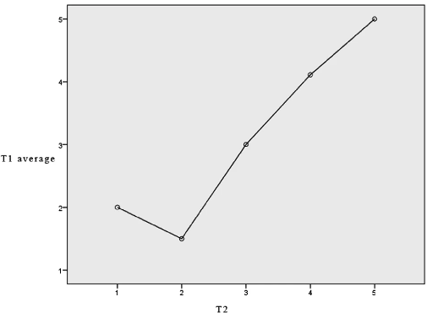Due to the relative range of educational aims and the dispersed nature of user wants, the education APP interface must be explicit about both its product goals and user needs. The effectiveness of educational APP products can only be ascertained when they are used by younger, older, mature, and adult populations. The user's demands are obviously to increase their professional level or learn material for fundamental education [10].

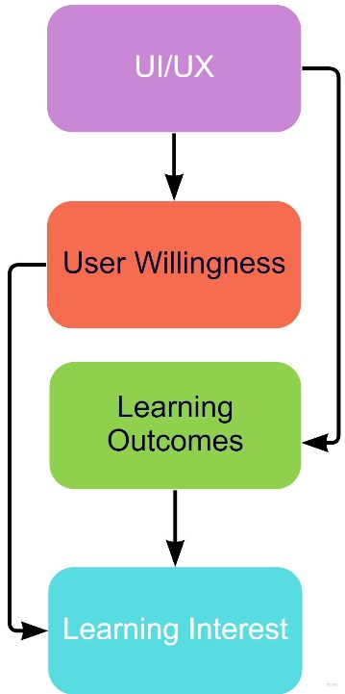The design goals define which features are necessary for the interface interaction design of educational APPs. The interface interaction design components must incorporate video material if the APP is built around the teaching style of live and recorded viewpoint. [10] The APP, however, is primarily built around a question bank, therefore the interface interaction design components should concentrate on the exercises and aid users in improving their learning outcomes through interactive design features like the in-depth justifications of incorrect questions.

As seen by the graph, more study reveals a general positive correlation between "User experience" and "User Willingness."

user experience : significantly influences whether a user is likely to use a product again, and this influence is favorably connected with learning outcomes.

User willingness : is significantly impacted by user-friendliness and entertainment, the User experience is greatly influenced by the way that content is presented, the interaction manner, and the design of the interface.

learning Outcomes : these are strongly influenced by user experience and user willingness, and user experience enhancement can also lead to greater user willingness.

Learning interest is a result of all these previous factors.

We can easily understand how numerous aspects interact when we organize their connection into a map.

According to research, the user experience design of HCI craft education applications has a strong emphasis on appearance and interaction, in contrast to other types of apps. The aesthetics of color and graphics, which are frequently valued, are not that significant. The major strategies to stimulate user interest in using educational applications again include designs that are fun and helpful to the user. The desire of users to use craft education applications may also be increased by improving the user experience. [12] Enhancements in these areas can be employed in practical design to raise learning effectiveness and interest

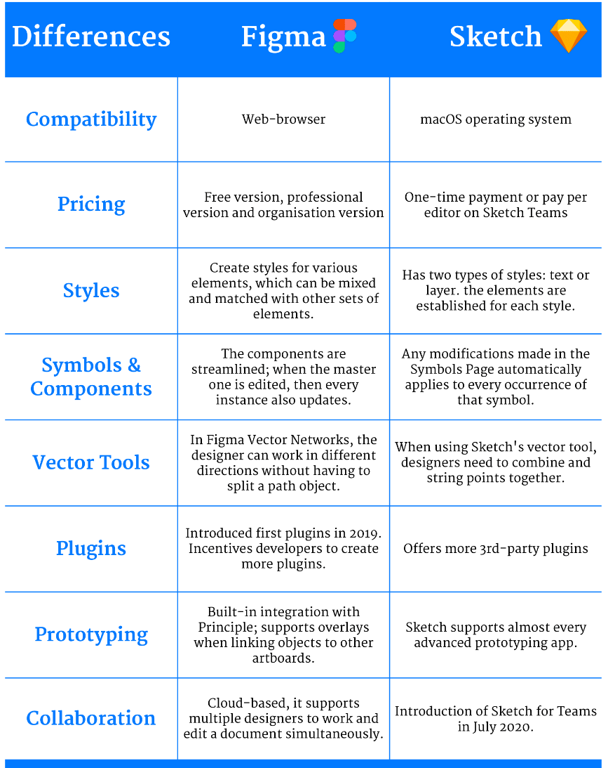So we now have to choose the tool that we will use in designing our app UI, there are two options for the tools Sketch and Figma and in this part, we will simply compare them to make sure that we make the right choice.

Finally, we choose the Figma tool to use in designing the UI of our app due to the tool's benefits.

**2.2.5. Why the games?**

A special type of computer software that is both entertaining and instructive is called educational games. In addition to efficiently promoting student learning and problem-solving skills development [32], it may deftly blend knowledge with games, create authentic problem situations for learners, and drive learning motivation [5].

Several advantages of educational games that led us to pick this way of learning include:

* Increases A Child’s Memory Capacity:

Memory, one of the main cognitive functions, and Games often revolve around the utilization of memorization, children have to remember aspects in order to solve the game [34].

* Helps With Fast Strategic Thinking & Problem-Solving:

Most games require children to think quickly [31]. Moreover, they have to utilize their logic in order to think three steps ahead in order to solve problems and complete levels. This is great because it is something that helps children in later life as they develop their logic, their accuracy, and their ability to think on their feet and outside of the box.

* Skill-Building:

A lot of games contain new skills that child didn't know before [33]. For example, learn the concepts of programming, and how to make software like games, Also learn the concepts of electric circuits.

According to this article [30], there is a serious game app called “Global Adventure” which is designed to promote children’s knowledge, skills, attitudes and values of global competence in the game. The game has the best effect on the improvement of the skills of the child which achieves three-level skills development of perception, conformation, and production.

Overall games develop and improve children's global competence during the learning process [30], Therefore, it seems that the effectiveness of learning throws games [29].

**2.2.6. Using a reward system**

Rewarding is one of the factors that influence student learning outcomes, so it is crucial to available of it, it’s tough to create an effective and efficient learning environment for young learners, they feel bored so quickly and get distracted all the time easily. At this young age, most of those children just want to play physical or digital games they are not interested in getting knowledge in a direct way or in the traditional way of studying so, it is essential to make

the students feel comfortable and enjoy learning [15] by using a reward system to maximize the understanding for the learning content [17][18].

According to [16], in this article, A group of teachers did an experiment on some of their students about giving rewards to the students and determining the effectiveness of it in the quality of learning, they got at the end of the experiment that is important that continuously give rewards to the students due to the positive effect on students’ learning, the rewards can make the students study harder or it can make the students feel fun during studying, its encourage students and motivate them, also they note that not all students interested with the verbal rewards given they prefer to get a tangible thing as a reward.

The research methods section in this article [17] contains a straightforward architecture that illustrates and discusses the general structure of the game reward model.

* 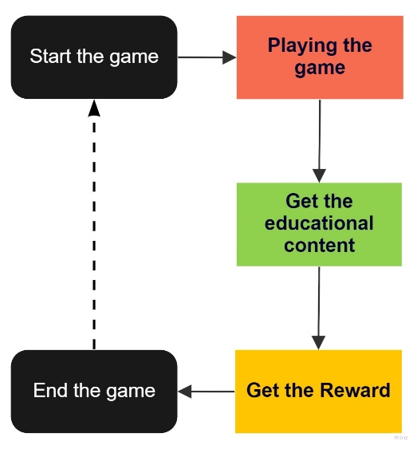Red box: the child begins to engage in play and begins to make crucial decisions, which will indicate that this child will pass this stage of play or not.
* Green box: This stage begins implicitly as soon as the child begins to play the game and continues till the game ends So, so the child gets the educational content indirectly.
* Yellow box: after the child finishes the game, he/she will get a reward as a motivation to make continuously play more games in the mobile app and gets more educational content.
* Dashed line: This is the application's default loop.

So, it is know very clear that traditional way in learning of child is a weak way to get knowledge also if the way of learning is by educational games also after some time will be bored for the child [17] to continue using the game. so, it is our objective to have a reward system in the educational app to get the best benefit of the process of learning.

**2.2.7. What is suitable educational content for children?**

Adaptive learning according to the ages of the children’s users who use the educational apps is a crucial step that we have to take care of it to build an effective mobile educational app [19] so, in this part we will explain why we have to use the adaptive learning method and how we will use it in our software.

It will not be fair if you provide the same educational content to all children of all ages. You do not know the carrying capacity of each generation of children. They face different challenges in relation to their ages in order to understand this educational content [20]. Therefore, we must separate the content that is offered to children of young age and children who are older than them. Trying to provide the best educational content suitable for all ages

The adaptation engine acquires input data and produces the adaptation results. Input data into the adaptation engine is the learner’s age. Output results of the adaptation engine are the adapted mobile educational content that suitable for this age [21]. There are several approaches in the field of mobile content adaptation for implementing adaptation engines, which include:

1. Adaptation rules, that is, when the child types of his age content adaptation are derived from conditional structures of if/then/else statements, which are based on previous studies.
2. Adaptation algorithms, that is, when the child types of his age content adaptation are derived from different types of algorithms such as heuristic algorithms, similarity algorithms, and decision-based algorithms.

**2.2.8. Chosen Framework**

choosing the right framework for software creation is one of the most important steps toward making good software due to the importance of the frameworks, it controls the application reliability and programming and testing efforts [23]. So, it will be important to choose the right framework wisely.

Every framework has its advantages and disadvantages, but there are still some core topics that we consider when we choose the framework for our software.

The following three factors were taken into account when selecting the framework for our software project:

* **Documentation**: Essential point as a good documentation means a better explanation on how everything works inside the framework and that will lead to a better implementation and use of the framework functionality.
* **Security**: Effective and reliable framework security is very important to any software because it protects the user's personal data and prevents it from being stolen [24].
* **Community Support**: the framework must have an active community of support. This is important to find a solution if we have any problems while implementing the software or we couldn’t find it in the documentation[26].

The Educational Game Design Framework is focused on producing

games that combines three main factors: game design, pedagogy and learning content modeling, Here is a list of the frameworks that we will choose from [38].

1. **Unity**

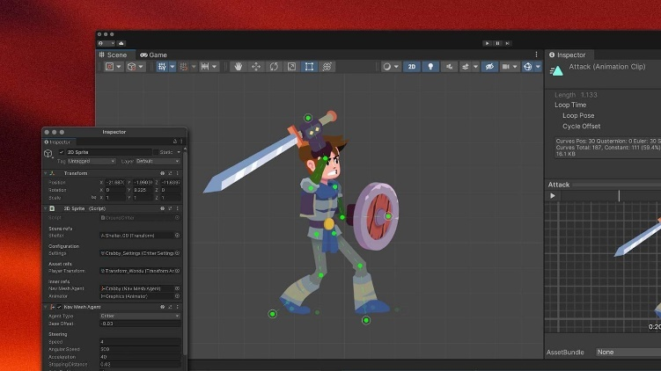It prides itself being a cross-platform game engine supported on Android, iOS and Linux. You can develop in a language of your choice consisting of C#, Boo or JS. It allows you to build game styles of 2D,3D, virtual reality and augmented reality. It’s flexible and well documented. Unity is a popular development platform and has an excellent support service offering many tutorials and guides, also there is a free version [36].

1. **Unreal Engine**

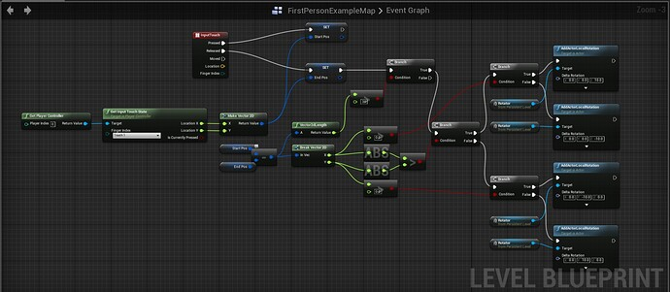Is a framework which requires no additional plug-ins. Unreal contains pre-built modular systems and customizable plug-ins. Its code is written in C++ and runs on over ten platforms. Similarly, it allows you to create virtual and augmented reality-style games [37].

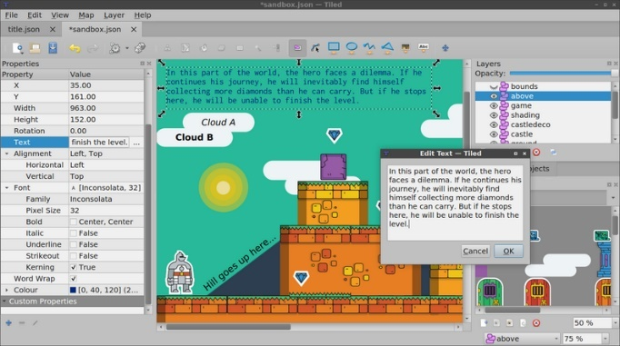

1. **libGDX**

It is a free, open-source, cross-platform framework. Licensed under Apache 2 you can build 2D or 3D games using Java as well as using some C++ and C components. It allows you to create games using the same code base for Linux, macOS, Windows, HTML5, Android, iOS and Blackberry. Therefore as a developer, you can write, test and debug your application. There is ever-growing community support with many tutorials provided by them and third parties.

1. **GODOT**

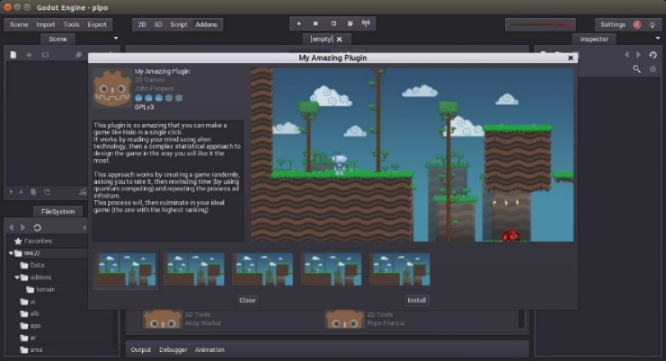An open-sourced and free cross-platform framework operating under the MIT license. GODOT allows for the construction of 2D and 3D games. Its games are built-in the C# or C++ language made for mobile, PC and web platforms. Similarly, it also has its own language if you choose to use GDScript. Currently, the platforms it supports are HTML5, iOS, macOS, Android, Windows, Blackberry 10 and many others. Alongside the code, GODOT features an animation system which has a range of original features [35].

Now our final choice fell on the duo Unity and Unreal Engine and now we will make a more accurate comparison for the final selection.

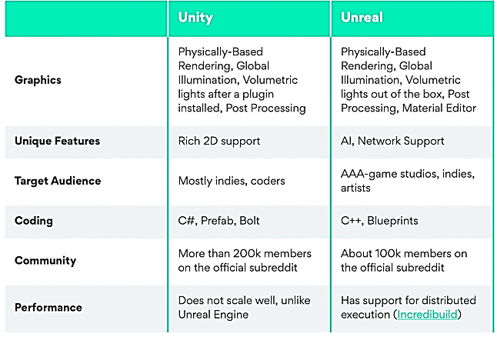

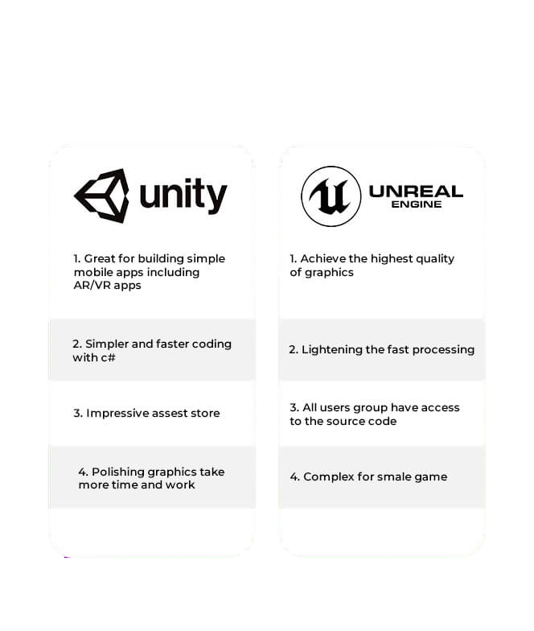

Finally, We chose Unity framework to implement our software project because of its huge benefits as:

* Easy to learn
* The engine is actively developing and getting more and more features each release.
* Huge range of supported platforms
* One of the biggest communities
* A lot of ready-to-use solutions and assets.

Also using the same code to many platforms, it reduces the cost and complexity of the app production while accelerating app development.

**2.2.9. Previous work**

In this section we will discuss past software’s that are have a similarity with our software project.

1. **prodigy**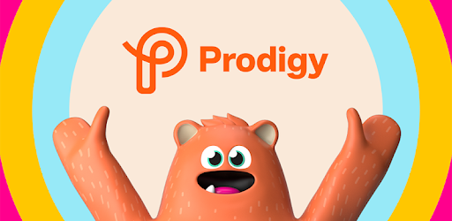

prodigy game is educational website for children containing various type of games like Mathematics and Language for kids, and they will described as follow:

* **Prodigy Math**

is the engaging math platform It’s curriculum-aligned, offering content from every major math topic from age 6 to 14 years, it contains some math battles and quizzes.

* **Prodigy Language**

This learning program is focus on learning the kids the words and letters of a chosen language in simple and visually pleasing way.

**Some of the advantages of the prodigy website are as follows:**

1. Teacher's progress track

Prodigy also provides multiple user accounts that are accessible to schools, teachers, and parents. Some of the key features for teachers include creating personalized assignments and Real-time tracking to identify each student’s daily progress.

1. Games Variety

Prodigy offers a variety of customized games that suit all children of all tastes.

**Some leading nonprofit organizations committed to helping children thrive describe some of the disadvantages of the prodigy website as follows:**

1. Selling memberships to kids.

Prodigy’s push to sell Premium memberships is relentless and aimed at kids. In just 19 minutes of “studying,” we saw 16 ads for membership and only 4 math problems. Ads take the form of videos and news feeds that showcase what Premium members can do those players without a membership cannot.

Premium memberships do not provide kids with access to a better learning tool. Instead, these memberships provide kids with bragging rights and digital goodies like cool hats and cute pets.

1. Distracts more than it teaches.

Too much onslaught of ads, and many of the in-game distractions are emotionally manipulative. Offers to rescue creatures, try new styles, chat with strangers, or try out new dance moves are hard for kids to resist, They focus on making the kid go shopping and character customization.

1. Teaches kids to be consumers, not learners.

Most of a child’s attention is drawn not to the educational game but to their character’s customization. In time considered independent learning, kids are buying and earning new accessories for their wizards and performing dance moves completely unrelated to the game’s plot. Children spend the most time in the outdoor section there, children can spin wheels to get more stuff and there are shops constantly available throughout the game—a known real-world sales tactic.

1. 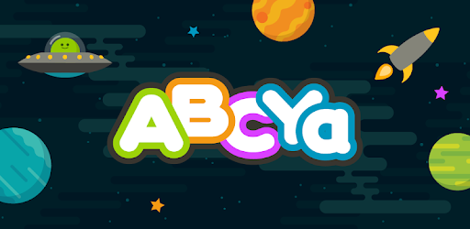**ABCya**

ABCya.com is a website that provides educational games and activities for school-aged children. The games on the website are organized into grade levels from pre-school to mid-school, as well as into subject categories such as letters, numbers, and holidays. Many of the games meet standards associated with the Common Core State Standards Initiative.

**Some of the advantages of the ABCya website are as follows:**

1. Hints System

how the games allow students to make mistakes and keep trying until they get the correct answer.

1. Reward System

games have incentives to get a certain amount of questions correct, which enables students to unlock certain features of the game.

**Some leading nonprofit organizations committed to helping children thrive describe some of the disadvantages of the ABCya website as follows:**

1. There's no progress tracking or learning support

There's no support for kids who don't know what game to choose or how to get through a difficult game.

1. continuous dispersion

If you don't pay the premium price for the ad-free version you will get bored of so many ads, it's even pretty easy for kids to click on the ads by mistake thinking they're clicking into a game. Each game has one or two banner ads.

1. Lack of the Arabic content

This educational site does not provide support for educational content in the Arabic language for children. It is only available in the English language, which will lead to difficulty in learning for children in the Arab world



**3) Scratch**

Scratch is a programming language recommended for kids over the age of 8 that was created by the MIT Media Lab. For younger children, there is even an alternative version of Scratch. It’s called ScratchJr and it can be used by kids aged 5-7 as it’s even simpler and more intuitive.

**Some of the advantages of the Scratch website are as follows:**

1. Scratch allows students to develop 21st century skills through the use of technology.
2. Scratch can be used by people of all ages including students from elementary- high school ages, and adults in a variety of settings.
3. A major advantage of scratch is that it is a free program so people can access and utilize scratch for both personal and academic use.

**Some leading nonprofit organizations committed to helping children thrive describe some of the disadvantages of the Scratch website as follows:**

1. User lack of training when using scratch. This could be on behalf of the teacher and student.
2. Teachers cannot monitor what students are creating in scratch. Inappropriate material may be used by the student that the teacher would have no knowledge of until they view the final scratch project.
3. Students under the age of 13 will need to use the email address of their parent or guardian, some student’s parent do not have email addresses which could be a barrier to when using scratch.

1. **Childsplay**



Childsplay is a collection of educational activities for young children, can be used at home, kindergartens and pre-schools ,  fun and save way to let young children use the computer and at the same time teach them a little math, letters of the alphabet, spelling, eye-hand coordination etc.

**Some of the advantages of the Childsplay software are as follows :**

1. memory activities that are fun to play and at the same time learn sounds, images, letters, and numbers.
2. train the child to use the mouse and keyboard in early age so he gets comfy using them in the future and help him type faster.
3. multilingual support to make it easy for any child to use it around the world and learn new languages if he wants
4. runs on Windows, MacOS, and Linux. So it’s usable for every computer and the parent does not need to download a special operating system

**Some leading nonprofit organizations committed to helping children thrive describe some of the disadvantages of the childplay software as follows:**

1. The biggest problem is that the childplay software contain a non-educational games which can lead the kid to play these games more than the educational ones and obtain zero benefit from the games and get addicted to non-educational games they made these games so the kid can have some fun while using the app but it mislead the education way of the software
2. The interface is hard to use does not contain any words or even hints to use the app it only made of icons and not a good one either.
3. **Gcompris**

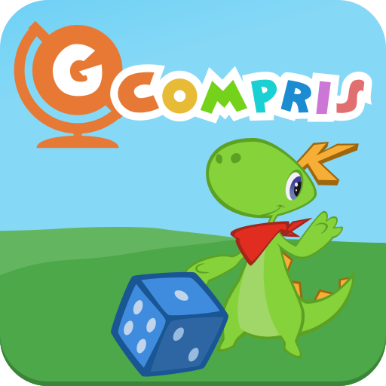

GCompris is an e-learning tool to provide training exercises within and outside the classroom. It is a Free Software released under the GNU General Public License. It is multiplatform.  including a large number of activities for children aged 2 to 10.

GCompris has been present for over twenty years in schools worldwide and offers more than 100 activities covering the main pedagogical domains

**Some of the advantages of the Gcompris software are as follows:**

1. Currently GCompris offers more than 100 activities which make it’s learning flexible and contain many information for the kids to learn
2. does not require an Internet connection, does not collect any data, and so strictly complies with the EU's General Data Protection Regulation which make your personal information secured and free of ads
3. grading functionality allows you to propose training exercises to pupils to practice mathematics, language, science and humanities.
4. Every game contain a manual to help the kid and the user to use the software

**Some leading nonprofit organizations committed to helping children thrive describe some of the disadvantages of the Gcompris software as follows:**

1. GCompris currently does not support iOS which made it a problem because now days many people use IOS operating systems in their homes and they can not use the software
2. No ability to separate users / groups: As result you cannot set two different activity for your children which make it annoying for the kids

After all the data has been collected, this section is summarized in a simple comparison between all the features of all the sites mentioned

|  |  |  |  |  |  |  |
| --- | --- | --- | --- | --- | --- | --- |
| Point | prodigy | Childs  Play | ABCya | Gcompris | Scratch | Our Software |
| progress track | Badge Tick1 with solid fill | **-** | **-** |  | **-** | Badge Tick1 with solid fill |
| Full Free | **-** |  | **-** | **-** | Badge Tick1 with solid fill | Badge Tick1 with solid fill |
| presence of ads | Badge Tick1 with solid fill | **-** | Badge Tick1 with solid fill | **-** | **-** | **-** |
| Hints System | **-** | **-** | Badge Tick1 with solid fill | **-** | **-** | Badge Tick1 with solid fill |
| Games Variety | Badge Tick1 with solid fill |  | Badge Tick1 with solid fill |  | **-** | Badge Tick1 with solid fill |
| Reward System | **-** | **-** | Badge Tick1 with solid fill | **-** | **-** | Badge Tick1 with solid fill |
| Arabic content | **-** | **-** | **-** | **-** | **-** | Badge Tick1 with solid fill |
| Training quizzes | **-** | **-** | **-** |  | Badge Tick1 with solid fill | Badge Tick1 with solid fill |
| Parent monitor | Badge Tick1 with solid fill | **-** | **-** | **-** | **-** | Badge Tick1 with solid fill |
| Programing content | **-** | **-** | **-** | **-** | Badge Tick1 with solid fill | Badge Tick1 with solid fill |
| Logic circuits content | **-** | **-** | **-** | **-** | **-** | Badge Tick1 with solid fill |
| Good  UI |  | **-** | **-** |  |  |  |

**2.3. conclusion**

Given that children are attracted to using mobile devices frequently, integrating the most recent mobile technologies with educational contexts offers them a beneficial learning experience.

Mobile-based learning which is embedded with the newest technology allows for collaborative peer learning and fruitful and meaningful learning experiences, in contrast to traditional classroom learning [28].

In order to provide kids with the best learning experience possible, we will provide them a suitable environment for them by making it as interactive and attractive as possible.

## **2 . 4 . System Analysis**

This section describes the final outline of our software project by detect the software methods and chosen framework.

From analyzing all the previously gathered data, we finally found the following:

### **2 . 3 . 1 Requirements**

**1) User Requirements**

**Functional Requirements:**

* 1. Parents Shall be able to make an account.
  2. All users Shall be able to Login with his/her account.
  3. All users Shall be able to logout from the app.
  4. All users Shall be able to delete his/her account.
  5. All users Shall be able to edit his/her account.
  6. All users Shall be able to track his/her achievements.
  7. All users Shall be able to track his/her progress of the game.
  8. All users Shall be able to collect points from passing the levels.
  9. All users Shall be able to spend his/her points on buying games or avatars.
  10. All users Shall be able to download his/her achievements.
  11. All users Shall be able to upload his/her personal image.
  12. All users Shall be able to change his/her wallpaper.
  13. All users Shall be able to play games.

**1) System Requirements**

**Functional Requirements:**

1) users of the system shall login to the application with their username and password.

2) Verify user is a function applied by sending verification code to the mobile.

3) each level of the game that user pass, he/she will get a reward in form of points.

4) users can spend their points in the app.

5) calculate the progress of the user.

6) collect achievements.

**Non-Functional Requirements:**

1. Performance
   * the system shall response in few seconds and it has more than one throughput .
2. Usability

* the system has only one view, user view which can play games

1. Security :

* Transaction data must be transmitted in encrypted form.
* No one can have the same username of any other user each one has his own.
* The system send message if you enter a uses username.

1. Supportability :

* The system application will run start from android 6 and above also on iOS 10 and above

### **2 . 3 . 2 UML Diagrams**

In this section, we will describe our software system with different types of diagrams like (Use case diagram, Database diagram, Activity diagram, Flowchart diagram, Package diagram, and Sequence diagram)

and this representation will help us to describe our software system well and make us understand our requirements and also take the best decisions will system implementation and testing.

In the following few pages, we will represent our system with the UML diagrams that have been mentioned previously and we will try to explain some of the diagrams with some UML tables that have much details of the diagrams.

**Our actors:**

1. Parent
2. Child

**Use case diagram:**

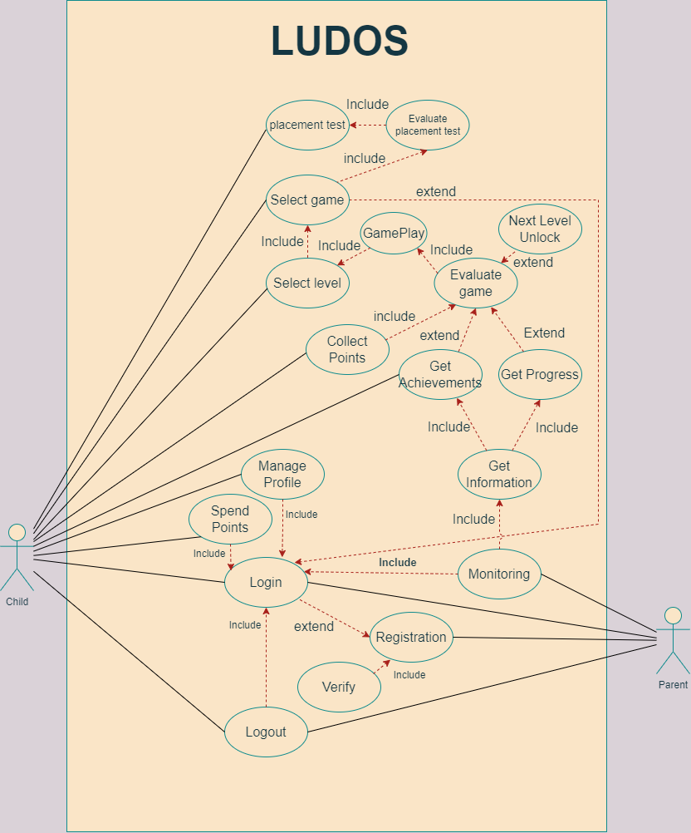

**Use case Tables:**

* Registration

|  |  |
| --- | --- |
| Use case id | 1 |
| Use case name | Registration |
| Actors | Parent |
| Precondition | Parent must have valid email to register with. |
| Post condition | parent registration occurred, and user must verify its account |
| Input data | Email , password, username |
| Description | User open the website and if he/she is a new user, he opens registration page.  user will enter the username, email and password, then the user press register, after that once verification process runs successfully, user registration is done, and user will be redirect to the login page. Also If the verification process failed, a message will appear to the user with the error while verification, user must try register again. |
| Comments & exceptions |  |

* Verify Account

|  |  |
| --- | --- |
| Use case id | 2 |
| Use case name | Verify |
| Actors | Parent |
| Precondition | Parent must enter his/her personal data in the registration page fisrt. |
| Post condition | Account registered |
|  |  |
| Input data |  |
| Description | User open the website, and after he/she done the registration phase an verification email will be sent to the user then he/she will open the email and press on the link to verify the account.  After that the user will be redirected to the login page. |
| Comments & exceptions |  |

* Login

|  |  |
| --- | --- |
| Use case id | 3 |
| Use case name | Login |
| Actors | Parent/Child |
| Precondition | User already created an account and account verified |
| Post condition | Logged in the website or in the application. |
| Input data | Username, Password |
| Description | Users open the application/website, then go to the login page, user enters the username and password and then press the login button, if login success, user redirect to home page, if login failed, a message will appear for the failed and ask the user to try again. |
| Comments & exceptions |  |

* Logout

|  |  |
| --- | --- |
| Use case id | 4 |
| Use case name | Logout |
| Actors | Parent/child |
| Precondition | User must be logged in firstly in the application/website |
| Post condition | Logout from the application/website |
| Input data | **-** |
| Description | Users open the application/website, then go to the settings page, then  Press on logout button. |
| Comments & exceptions |  |

* Placement test

|  |  |
| --- | --- |
| Use case id | 5 |
| Use case name | placement test |
| Actors | child |
| Precondition | **-** |
| Post condition | Show the score for the user |
| Input data | **-** |
| Description | The child opens the application for the first time this will not appear again |
| Comments & exceptions |  |

* Evaluate placement test

|  |  |
| --- | --- |
| Use case id | 6 |
| Use case name | evaluate placement test |
| Actors | child |
| Precondition | placement test must be completed |
| Post condition | go to home page |
| Input data | - |
| Description | the application calculates or predicts the user's age throw the placement test and opens the appropriate games for him |
| Comments & exceptions |  |

* Select game

|  |  |
| --- | --- |
| Use case id | 7 |
| Use case name | select game |
| Actors | child |
| Precondition | placement test score |
| Post condition | select level |
| Input data | - |
| Description | user can select the game in the appropriate games that open for him based on the placement test score |
| Comments & exceptions |  |

* Select level

|  |  |
| --- | --- |
| Use case id | 8 |
| Use case name | select level |
| Actors | child |
| Precondition | Select game |
| Post condition | play game |
| Input data | - |
| Description | every game contains a bunch o levels just the first level will be open in every new game the user unlock |
| Comments & exceptions |  |

* Play game

|  |  |
| --- | --- |
| Use case id | 9 |
| Use case name | play game |
| Actors | Child |
| Precondition | Select level |
| Post condition | Evaluate score |
| Input data | - |
| Description | once you select the level the game will be started |
| Comments & exceptions |  |

* Evaluate game

|  |  |
| --- | --- |
| Use case id | 10 |
| Use case name | evaluate game |
| Actors | child |
| Precondition | Playing any level at any game |
| Post condition | open next level |
| Input data | - |
| Description | after finishing the game in a specific time, the app will calculate the points you collect or the achievement you will get and your progress in the game |
| Comments & exceptions |  |

* Next level unlock

|  |  |
| --- | --- |
| Use case id | 11 |
| Use case name | Next level unlock |
| Actors | child |
| Precondition | Playing and win the level |
| Post condition | Evaluate game |
| Input data | - |
| Description | you finished the level with a win, after the game calculates the points, the next level will be unlocked |
| Comments & exceptions |  |

* Collect points

|  |  |
| --- | --- |
| Use case id | 12 |
| Use case name | collect points |
| Actors | child |
| Precondition | finish level |
| Post condition | Evaluate game |
| Input data | - |
| Description | after finishing every level, you will get points depending on the time you finish the level. |
| Comments & exceptions |  |

* Get achievement

|  |  |
| --- | --- |
| Use case id | 13 |
| Use case name | get achievement |
| Actors | child |
| Precondition | win the game |
| Post condition | Evaluate game |
| Input data | - |
| Description | -- |
| Comments & exceptions |  |

* Get progress

|  |  |
| --- | --- |
| Use case id | 14 |
| Use case name | get progress |
| Actors | child |
| Precondition | Playing the level |
| Post condition | Evaluate game |
| Input data | - |
| Description | -- |
| Comments & exceptions |  |

* Mange profile

|  |  |
| --- | --- |
| Use case id | 15 |
| Use case name | mange profile |
| Actors | child |
| Precondition | User already created an account and account verified |
| Post condition | Change the name or avatar or wallpaper |
| Input data | - |
| Description | Users open the application, then go to the profile page there you can change the name, avatar, and wallpaper |
| Comments & exceptions |  |

* spend points

|  |  |
| --- | --- |
| Use case id | 16 |
| Use case name | spend points |
| Actors | child |
| Precondition | User already created an account and account verified and play games |
| Post condition | buy an avatar and wallpaper |
| Input data | - |
| Description | If you have an account and play any game that means you have collect points, to spend it you have to go to the shop and buy what you can buy |
| Comments & exceptions |  |

**Use Case Scenario tables:**

* Registration

|  |  |
| --- | --- |
| Scenario id | 1.1 |
| Scenario name | Success User Registration |
| Target use case | User Registration |
| Scenario events | Users register with valid Email and the verify the account so user registration happen successfully |

|  |  |
| --- | --- |
| Scenario id | 1.2 |
| Scenario name | Fail User Registration |
| Target use case | User Registration |
| Scenario events | Users register with invalid Email so user registration happen unsuccessfully |

* Verify Account

|  |  |
| --- | --- |
| Scenario id | 2.1 |
| Scenario name | Success account verification |
| Target use case | Verify |
| Scenario events | User enter his/her a valid email and a verification link will be sent to this email, User will click on the link, then it will be successfully verified, and finally user will be redirect to home page |

|  |  |
| --- | --- |
| Scenario id | 2.2 |
| Scenario name | Fail account verification |
| Target use case | Verify |
| Scenario events | User enter his/her a wrong email and a verification link will not be sent to the email then it will be unsuccessfully verified. |

**Class diagram:**

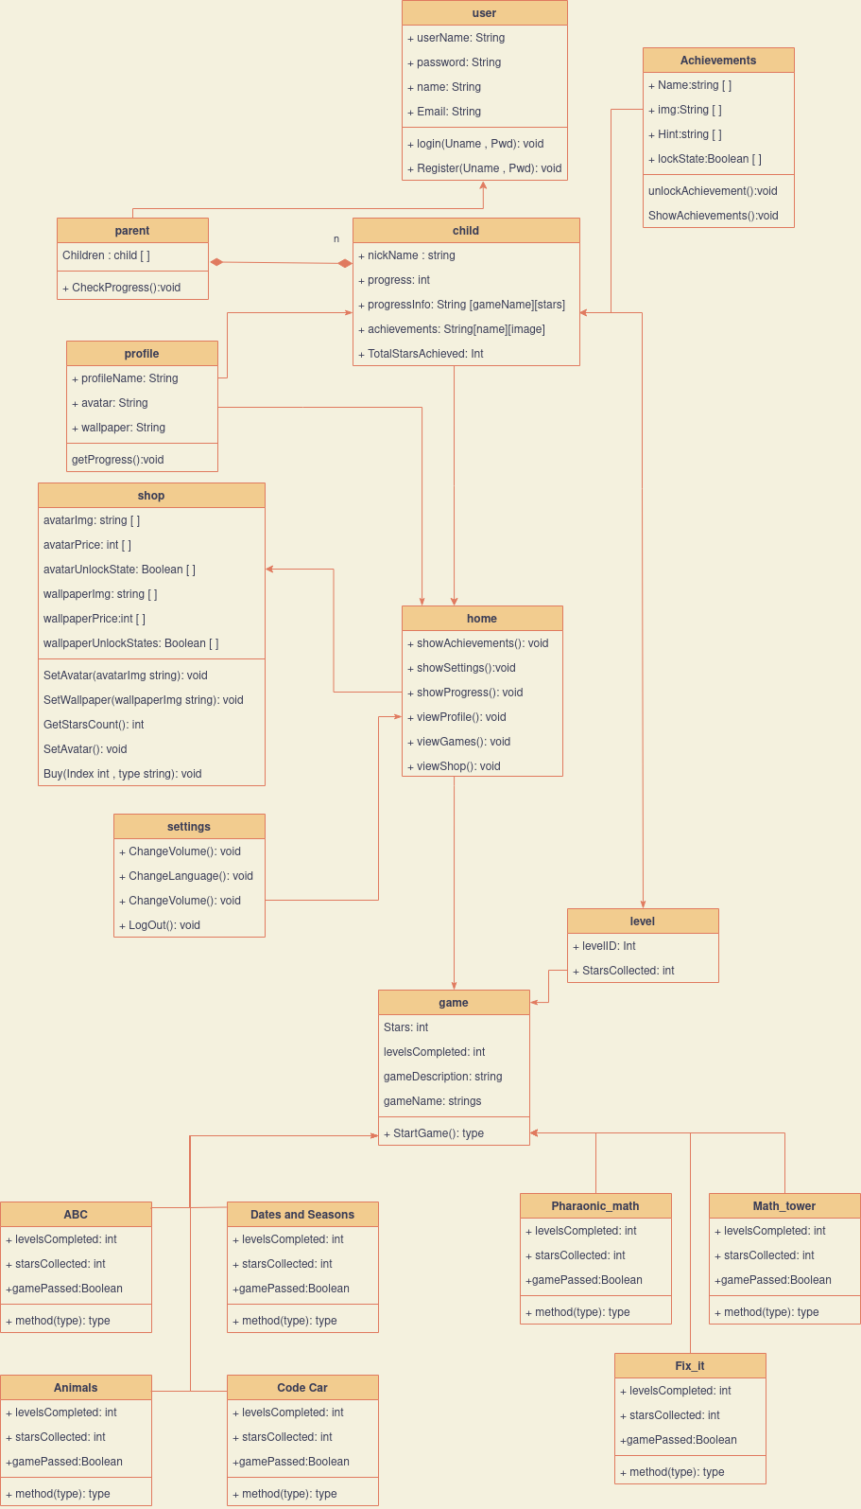

**Database Diagram:**

**ERD**

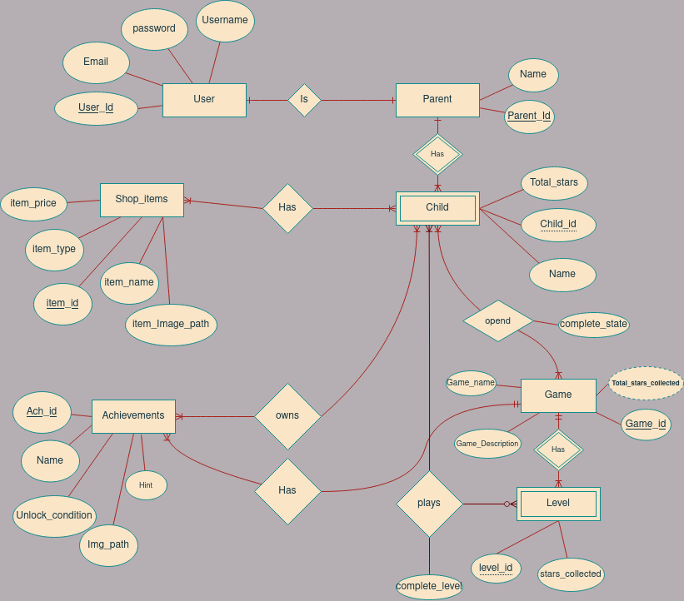

**Schema**

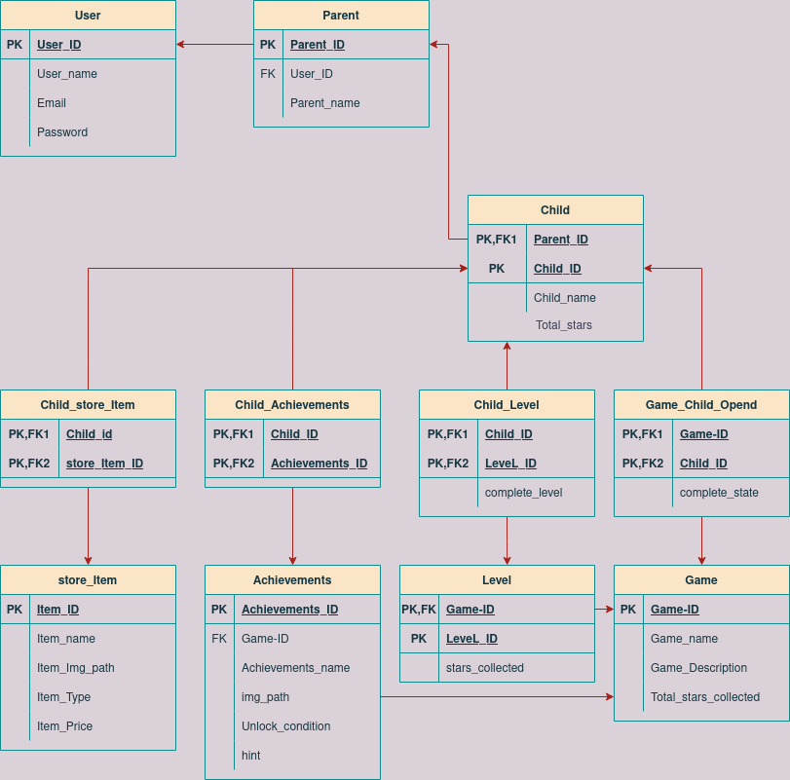

**Description:**

• Proposed entities (User, Parent, Child, Game, Level, Achievements, Shop_item) that belong to the system

• Proposed attributes, it shows in each table.

**Tables:**

• User

* User_id
* User_Username
* User_Email
* User_Password

• Parent

* Parent_id
* Parentr_name

• Child

* Child_id
* Child_name

• Game

* Game _id
* Game _name
* Game _describtion
* Game _completed
* Game _Total_Star_completed

• Achievements

* Achievements _id
* Achievements _name
* Achievements _Hint
* Achievements _Target
* Achievements _Image_path

• Level

* Level _id
* Level _Stars_Collected
* Level _Complete_State

• Shop_item

* item _id
* item _name
* item _Price
* item _Type
* item _Image_path

**Activity diagram:**

**Child**

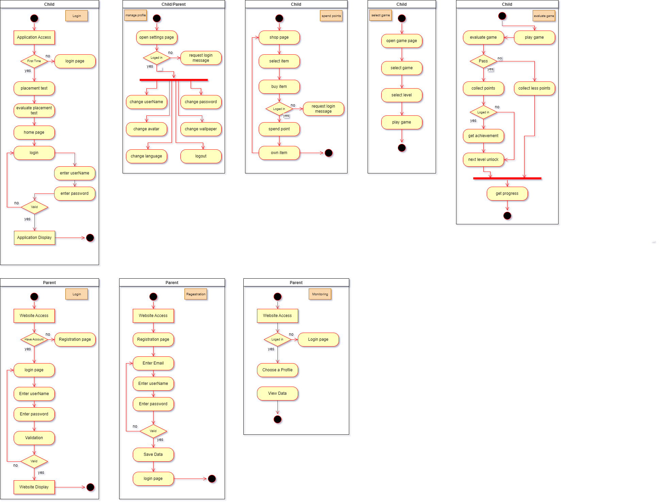







**Parent**





**Software Flow Chart:**

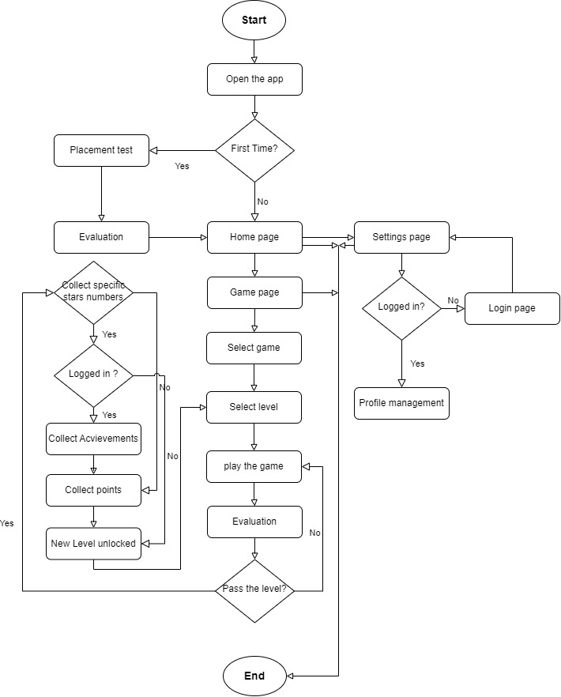

**Sequence diagram:**

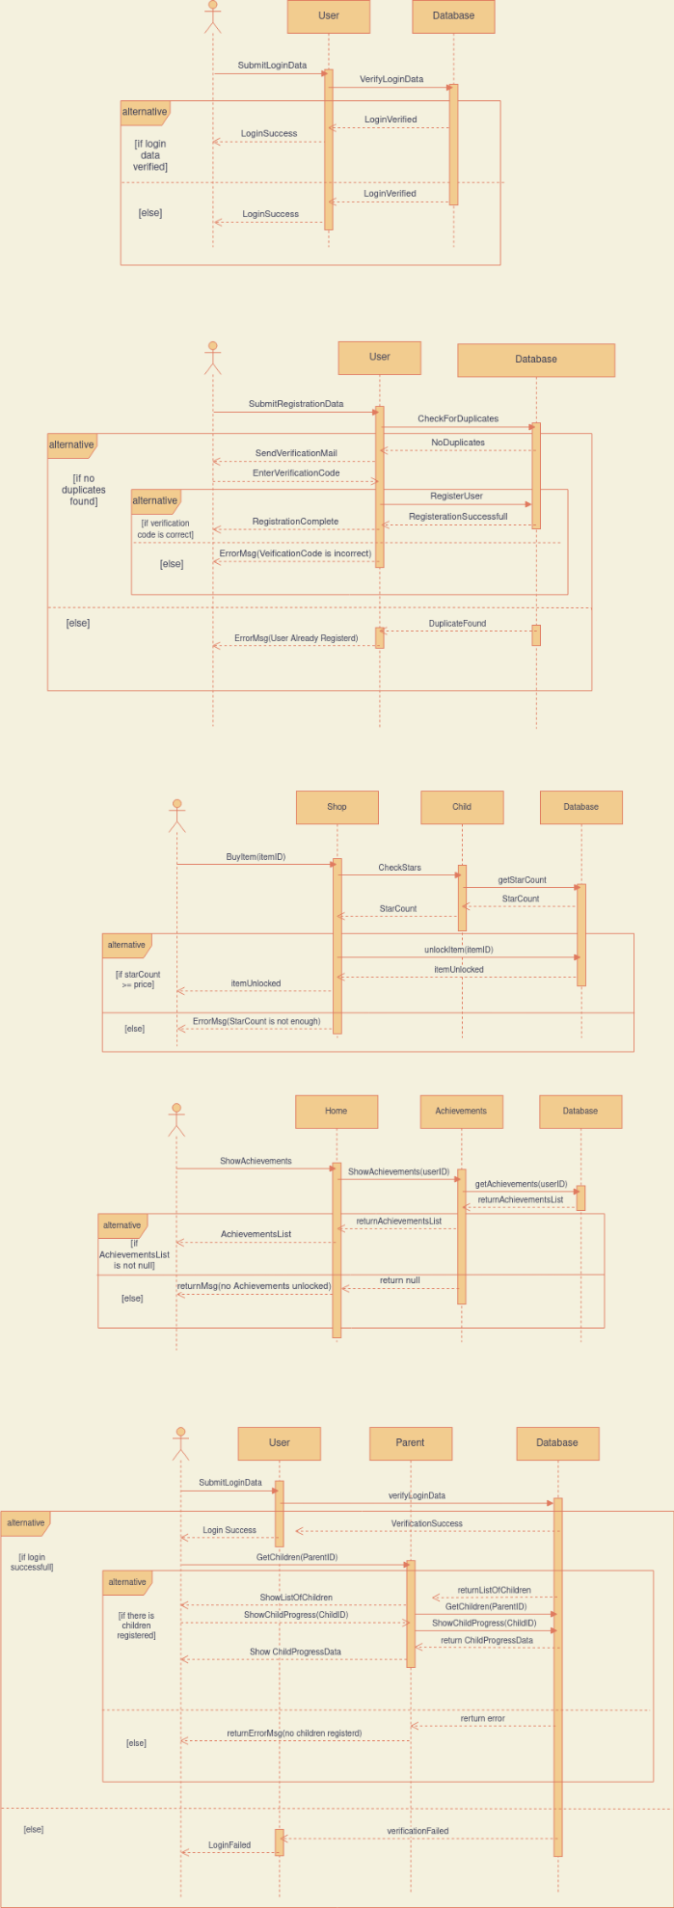



## **2 . 4 . System Model**

This Section will illustrate the meaning of software architecture and how it improves the productivity and quality of the software, also we will describe the points that we took in view to make software architecture for our project.

**What is the Software Architecture?**

The design stage in software development is a process by which the conceptual model obtained in the requirements stage is transformed into another model which is capable of being implemented. The software architecture of a computing system is the overall structure of the system which comprises software components and the interactions among them[39].

**Benefits of software architecture.**

By now we must have understood that good software architecture is extremely important for our software project. So here are some points of benefits that we took in view to make our software architecture[40].

* It creates a solid foundation for our software.
* Increases performance of the platform.
* Providing a big-picture vision of the software.
* Better code maintainability.
* Helps manage complexity.
* risk management.

**Our Educational Game Architecture**

According to the requirements that we chose our software should provide four main functionalities:

* Providing hints to the players in the Arabic language.
* Representing the learning content with appropriate elements.
* Providing quizzes to the players to test their understanding.
* Giving players rewards to keep them motivated.

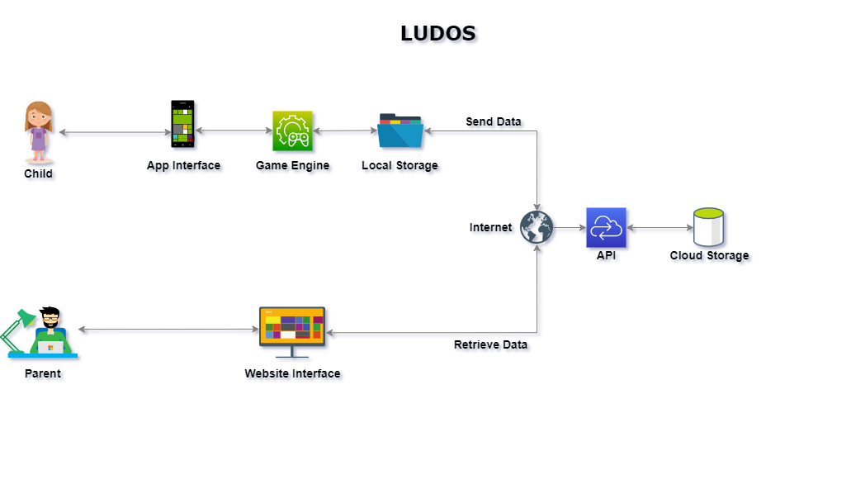**Our Architecture**

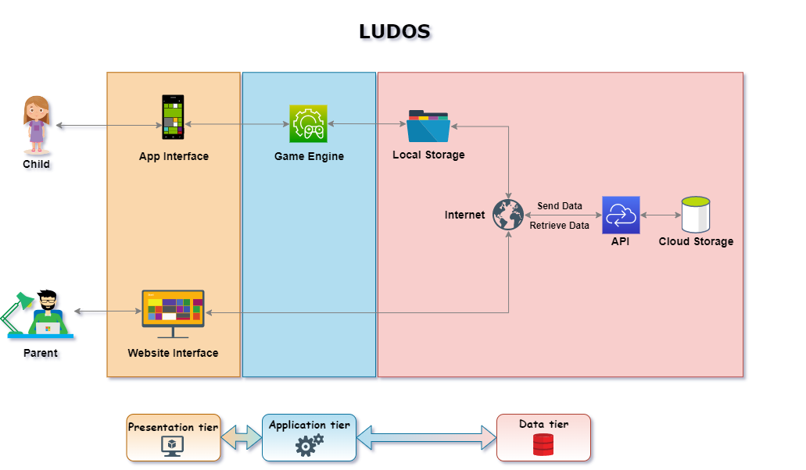

**Our software architecture is split into three tires.**

**Presentation tier**

The presentation tier is the user interface and communication layer of the application, where the end-user interacts with the application. Its main purpose is to display information to and collect information from the user. This top-level tier runs on our web browsers and mobile app.

Web presentation tiers are developed using HTML, CSS, and JavaScript, and mobile presentation tiers are developed using Unity.

**Application tier**

The application tier, also known as the logic tier or middle tier, is the heart of the application. In this tier, information collected in the presentation tier is processed.

The application tier can also add, delete or modify data in the data tier.

The application tier is developed using Unity and communicates with the data tier using API calls.

**Data tier**

The data tier, sometimes called database tier, data access tier, or back-end, is where the information processed by the application is stored and managed.

In our software we used two types of databases first is a local database to store the game assets and the player progress, and the second is a cloud database to store the account information and the progress of the player

In the three-tiers, all communication goes through the application tier. The presentation tier and the data tier cannot communicate directly with one another.

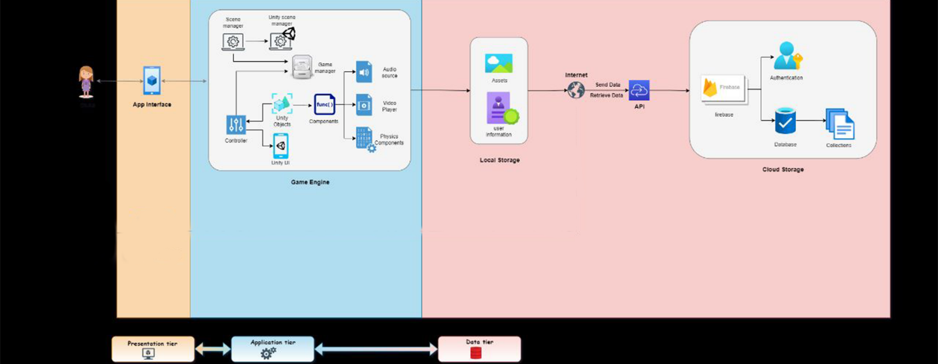

**Sequence of the API:**

**Previous System Model:**

This Section will illustrate the software architecture of the other platforms that main goal is to provide educational games for children like our software.

**1)**

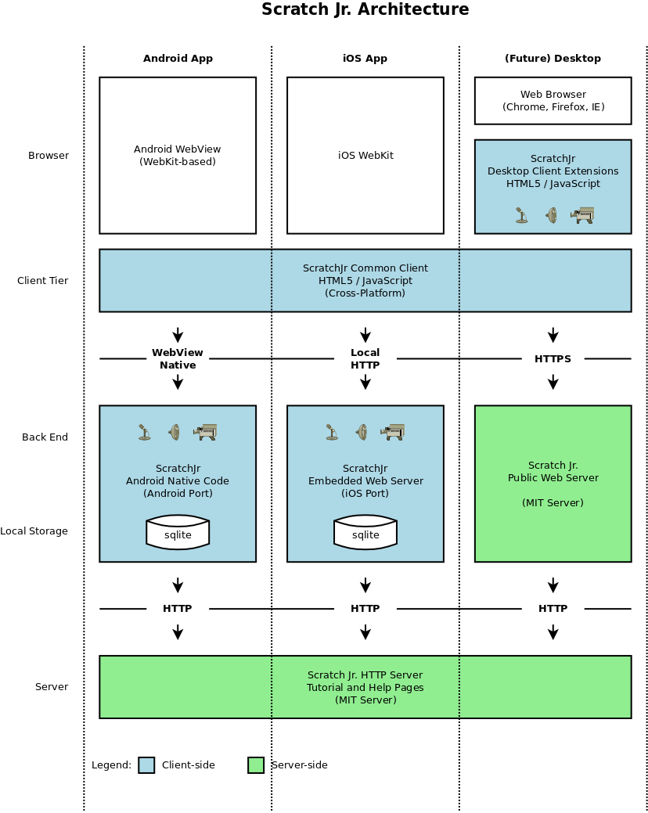

Our first Software Architecture belongs to scratchJr platform, Scratch is designed specifically for young people (ages 8 and up) to help them develop 21st-century learning skills: thinking creatively, communicating clearly, analyzing systematically, using technologies fluently, collaborating effectively, designing iteratively, and learning continuously.

ScratchJr is a derivative of the Scratch language, which has been used by over 10 million people worldwide. Programming in Scratch requires basic reading skills, however, so the creators saw a need for another language that would provide a simplified way to learn programming at a younger age and without any reading or mathematics required.

ScratchJr is available as a free app for iOS, Android, ScratchJr Software Architecture splits into two tires:

**Client tier**

This tier contains two layers:

The presentation layer: Contains the user interface where the end-user interacts with the application. Its main purpose is to display information to the user and collect information from the user. This top-level tier runs on the mobile app.

The presentation layer is developed using Android WebKit and IOS WebKit.

The Data layer: contains the database of the software, the type of the database is a local database to store the game assets and the player's progress.

The Data layer is developed using SQLite.

**Server tier**

Contains the landing page that has tutorials and a help page.

The server tier is developed using HTML5 and Javascribt and communicates with the Client tier using API calls, In the two tiers.

all communication goes through API calls.

**Benefits of the software architecture.**

Here are some points of benefits that we took in the view of the ScratchJr Software Architecture

• Available for iOS, and Android.

• Local Storage.

• Landing page available.

2)

In Figure below we have a diagram which contains the different elements that make up the architecture:

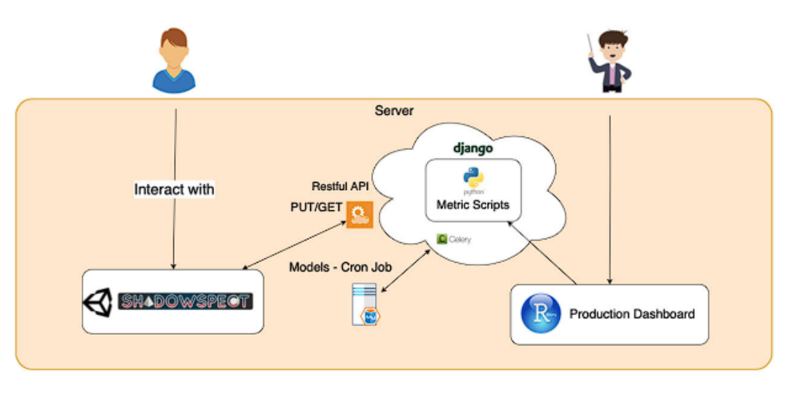

Shadowspect: This module represents the geometry game that was developed for game-based assessment. The game has been built using Unity Engine and deployed as a web application hosted in a web server. This facilitates accessing the game from multiple devices and without having to install any software to do so. Also, the game was developed as lightweight as possible, since we need students using Chromebooks or similar low capacity computers in schools to be able to use it.

Server backend with Django: The main backend of the server has been built using the Django framework based on Python. Shadowspect communicates with this Django server using a RESTful API. Django also communicates with a MySQL database where all the necessary models have been defined. One of the challenges is keeping the metrics data up to date to make this a real-time dashboard. To do so, we use Celery, a task queue implementation for Python web applications used to asynchronously execute work outside the HTTP request-response cycle [54], so that we can schedule a cron job to execute the Python scripts every ten minutes and keep the metric’s output updated.

Analytics processing: Each one of the metrics that we have defined is a separate function that computes the required data output as defined in a Python script. These functions are called by the cron job that updates the data, the Python scripts directly import data from the MySQL database, computes the metric, and stores the metric output in the MySQL database, so that is directly accessible without delay.

Dashboard: We have developed the dashboard using Shiny’s R framework, and we have deployed it on ShinyApps web server. This brings a good number of benefits, such as that the entire deployment pipeline is very easy as it does not need any hardware or configuration of the system. ShinyApps is also secure-by-design with each application using its own protected environment, and access is always SSL encrypted. Finally, the resources allocated to the dashboard are scalable and we do not need to worry about balancing backend resources based on the system’s current workload.

Users: We have two kinds of users. On the one side, we have the students, that interact with Shadowspect generating the trace data with their interaction with the game. On the other side, we have the teachers, that are using Shadowspect in their classes and are the ones that can access the Shiny dashboard production environment to visualize what their students are doing.

**Benefits of the software architecture.**

Here are some points of benefits that we took in the view of the Software Architecture

• accessing the game from multiple devices.

• Local & online Storage.

• real-time dashboard.

In Figure below we have a diagram which contains the different elements that make up the architecture:

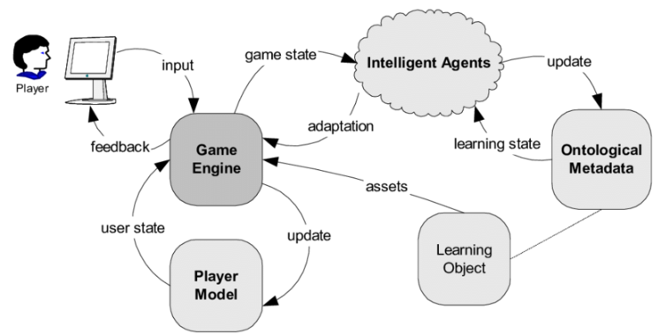

Game engine: This module represents the intermediate point between the user and the database and the system engine.

The game has been built and deployed as a desktop application hosted in locally on the user machine. This facilitates the processing process. Also, the game was developed as lightweight as possible, since we need students using low capacity computers to be able to use it.

Player model: The main backend of the user has been built using the .Net framework based on Python. game engine communicates with this database using local communication trafics to get and save all the user status.

Learning object: The main backend of the software has been built using the .Net framework based on Python. game engine communicates with this database using local communication trafics also all the necessary models have been defined there. One of the challenges is keeping the metrics data up to date to make this a real-time dashboard. To do so, we use ontilogical meta data database to save the important data of the user to prevent it from being lost.

Player: We have one kind of user. On the one side, we have the students, that interact with game engine generating the trace data with their interaction with the game.

**Benefits of the software architecture.**

Here are some points of benefits that we took in the view of the Software Architecture

• locally installed in one device.

• Local Storage.

• fast processing.

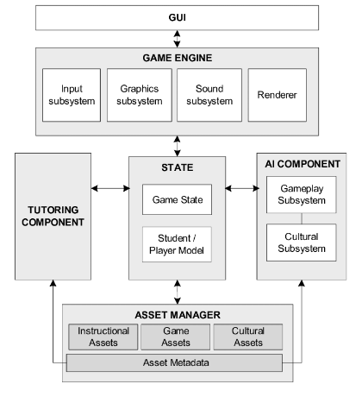4)

In Figure above we have a diagram which contains the different elements that make up the architecture:

GUI: This is the part that works as the client layer that interacts with the users, We have one kind of user. On the one side, we have the students, that interact with the GUI that interact with the game engine generating the trace data with their interaction with the game.

Game engine: The core functionality typically provided by a game engine may include a rendering engine for the graphics, sound, scripting, and animation, its work as a connection point between the front end and the back end of the software.

State: This is the part that works as the connection point between the game engine and the AI components and the database part.

Asset manager: The main backend of the software it stores the software's important information like the game assets and the game sounds and the player status.

AI components: Serious game AI functionalities include player modelling (real-time facial emotion recognition, automated difficulty adaptation, stealth assessment), natural language processing (sentiment analysis and essay scoring on free texts)

**Benefits of the software architecture.**

Here are some points of benefits that we took in the view of the Software Architecture

• locally installed in one device.

• Local Storage.

• AI components.

5)

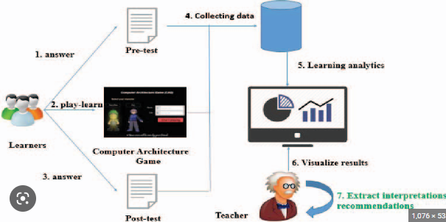

In Figure above we have a diagram which contains the different elements that make up the architecture:

GUI: This is the part that works as the client layer that interacts with the users, We have one kind of user. On the one side, we have the students, that interact with the GUI that interact with the game engine generating the trace data with their interaction with the game.

Computer architecture game: The core functionality typically provided by a game engine may include a rendering engine for the graphics, sound, scripting, and animation, its work as a connection point between the front end and the back end of the software.

Also contain the computational part of the software and after getting the results from analyzing the tests that the user passed it this component send the result back to be saved in the database of the software.

Database: The main backend of the software it stores the software's important information like the game assets and the game sounds and the player status.

Users: We have two kinds of users. On the one side, we have the students, that interact with database generating the trace data with their interaction with the game. On the other side, we have the teachers, that are using database in their classes and are the ones that can access the Shiny dashboard production environment to visualize what their students are doing.

**Benefits of the software architecture.**

Here are some points of benefits that we took in the view of the Software Architecture

• two kind of users.

• Local Storage.

• learn analysis.

**Our Architecture:**

After all the data has been collected, this section is summarized and illustrated in a simple comparison between all the architectures of all the educational software mentioned before.

also we will describe the points that we took in view to make software architecture for our project.

|  |  |  |  |  |  |  |
| --- | --- | --- | --- | --- | --- | --- |
| Point | [1] | [2] | [3] | [4] | [5] | Our Software |
| Local storage |  | **-** |  |  |  | Badge Tick1 with solid fill |
| Online storage | **-** |  | **-** | **-** | - | Badge Tick1 with solid fill |
| AI | - | - | Badge Tick1 with solid fill |  | **-** | **-** |
| Report generation | - |  | - | **-** |  | Badge Tick1 with solid fill |
| Locally installed |  | - | Badge Tick1 with solid fill |  |  | Badge Tick1 with solid fill |
| Fast processing |  | **-** |  |  |  | Badge Tick1 with solid fill |
| API | - |  | **-** | - | - | Badge Tick1 with solid fill |
| Two types of users | - |  | **-** | **-** | - | Badge Tick1 with solid fill |
| Online access | - |  | **-** | **-** | - | Badge Tick1 with solid fill |

# 3 . Chapter Three: System Design

## 3 . 1 . **System GUI**

3 . 1 . 1 Mobile Application

Login Signup Add child

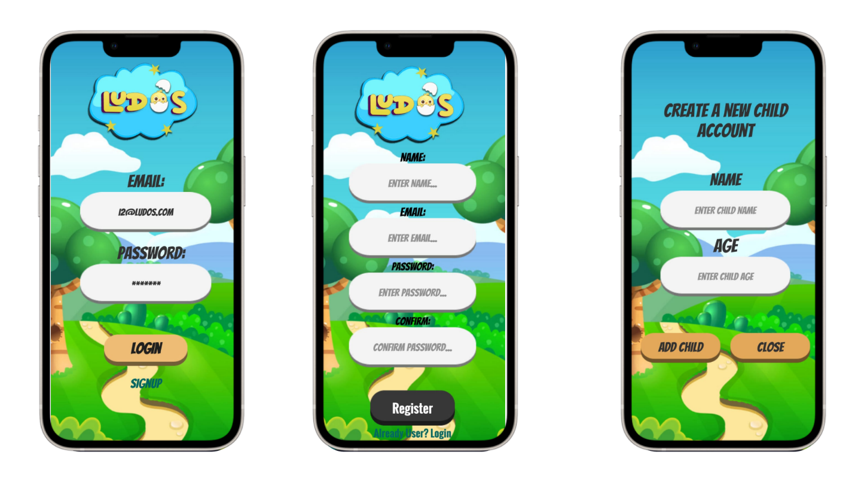

Main menu achievement settings

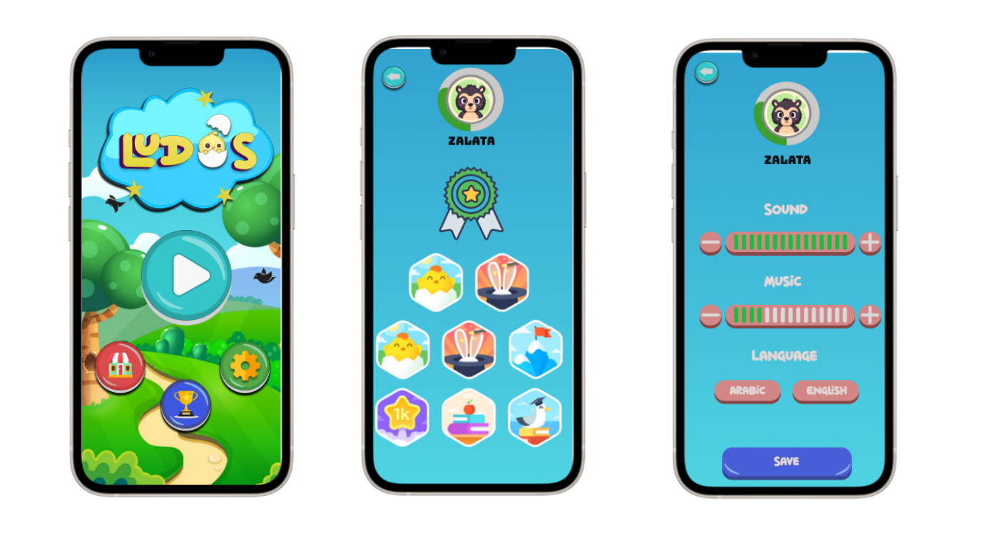

Game Select Shop

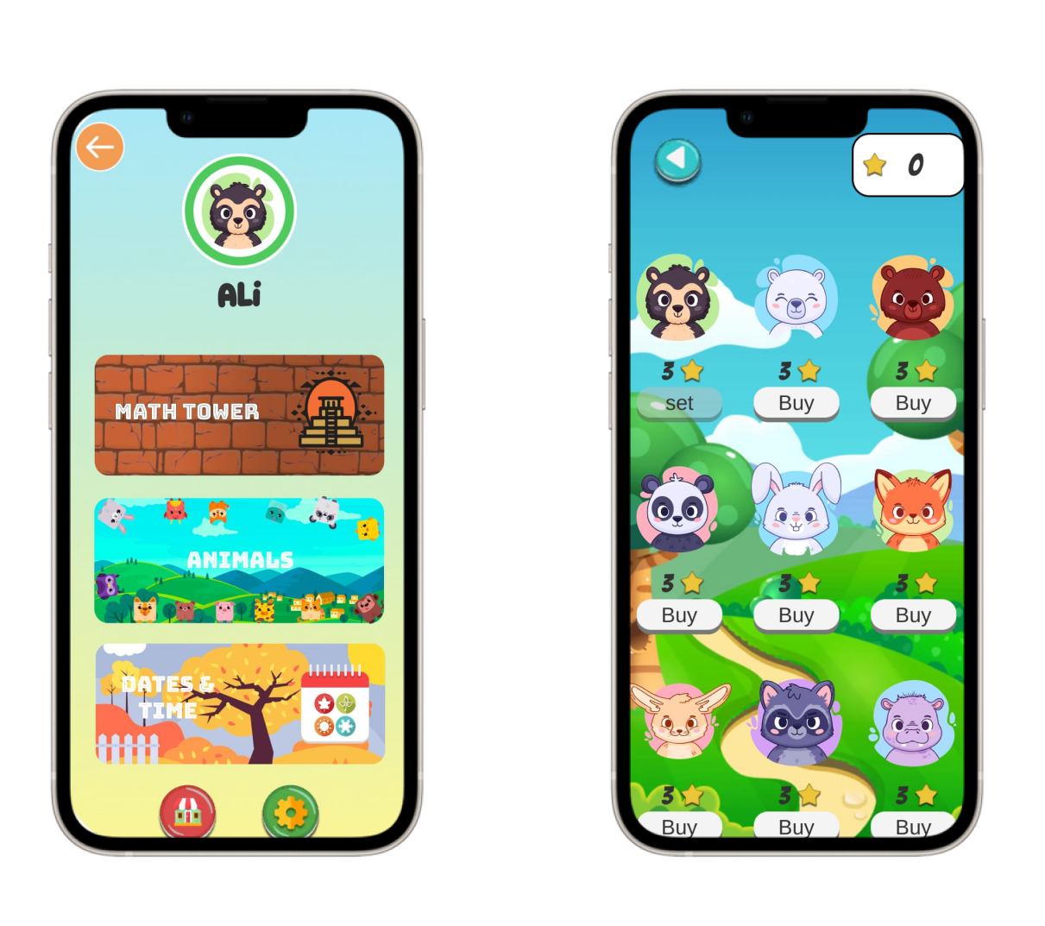

## 3 . 2 . **Games Manuals**

|  |  |  |  |
| --- | --- | --- | --- |
| Math Tower | **Description** | **Game Structure** | |
| Math learning game that challenges kids to solve mathematical problems in order to progress or score points. It features several mini-levels, and the more they do the better their math skills will become! | **levels** | **5** |
| **points** | **3 per level** |
| **outcomes** | **achievements** | 2(babysteps,15)(cliverbaby,30) |
| Our game give students opportunities to explore fundamental number concepts, Improved fluency in arithmetic operations such as addition, subtraction  Increased proficiency in problem-solving and critical thinking.  A deeper understanding of mathematical concepts.  Greater confidence and motivation in learning and using math.  Development of a growth mindset and a positive attitude towards learning math. | **User flow** | When the user open the game he/she will found a bunch of levels which curriculum has been divided on it in a correct way to get the best learning.  when the user start the level he/she will notice that the screen is divided to three sections, The first one lay on the top of the screen and contains the navigations & Time information, The second section lay on the middle of the screen and contains the game information like the questions that will be displayed to the user, Third section lay on the bottom of the screen and contains arrows which help the user to move the animated character and make him go left or right then jump to confirm his answer if he chooses the right answer the brick will be wider but if he choose the wrong answer he will go down but he can still jump to the right answer.  There will be Animate scenes and characters which will help the user to pass the level successfully. |

|  |  |  |  |
| --- | --- | --- | --- |
| Animals | **Description** | **Game Structure** | |
| The game include informative and educational content that teaches kids about different animals and their characteristics. This could include information about the animal's habitat, physical features, behavior, and adaptations. Also engaging and fun while also imparting knowledge and fostering a love of learning about the natural world | **levels** | **5** |
| **points** | **3 per level** |
| **outcomes** | **achievements** | 2(babysteps,15)(cliverbaby,30) |
| The main goal of this game is to add new information to the user about different animal types and help cultivate an interest in animals and the natural world among kids. Kids may become more curious about the animals they encounter in their daily lives and may develop a desire to learn more about them. Also improve cognitive skills such as memory, attention, and problem-solving. This is because kids need to remember facts, pay attention to details, | **User flow** | When the user open the game he/she will found a bunsh of levels which curriculum has been divided on it in a correct way to get the best learning.  when the user start the level he/she will notice that the screen is divided to three sections, The first one lay on the top of the screen and contains the navigations & Time information, The second section lay on the middle of the screen and contains the game information like the questions that will be displayed to the user as a button when you hit on it a women voice will appear and till you the question again, Third section lay on the bottom of the screen and contains the answer of the question in form the animals figure so when he knows the right answer he will also know the animal body looks like. |

|  |  |  |  |
| --- | --- | --- | --- |
| Date/season’s | **Description** | **Game Structure** | |
| The game could help kids navigate a calendar and learn the names of the months and the four seasons . This could be achieved through interactive exercises where kids can select a date on a calendar | **levels** | **5** |
| **points** | **3 per level** |
| **outcomes** | **achievements** | 1(Junior) |
| Beside learning the names of the months and the seasons with each season main characteristics, kids can improve their memory skills and recall information more easily. | **User flow** | When the user opens the game he/she will find a bunch of levels in which the curriculum has been divided on it in the correct way to get the best learning.  when the user start the level he/she will notice that the screen is divided to three sections, The first one lay on the top of the screen and contains the navigations & Time information, The second section lay on the middle of the screen and contains the game information like the questions that will be displayed to the user, Third section lay on the bottom of the screen and contains the answer of the question in form of buttons when he chose the right answer the buttons color will be green and a women voice will till him it’s the right one but if he choose the wrong answer the button will go red and till him to try again . |

# 4 . Chapter Four: System Implementation

## 4 . 1 . **User interface implementation**

Before we implement the interface, we carefully studded the science of UI which led us to study first the user, his needs, behavior and more.

Our top priority was to make sure that the interface is easy to understand, navigate, and use. This includes clear and consistent labeling of buttons and controls, logical flow of actions, and intuitive navigation. We should also provide feedback to users about the outcome of their actions, secondly ensure that our interface is usable by all users, including those with disabilities. We need to follow accessibility guidelines and ensure that our interface is designed to be accessible to users with visual, hearing, mobility, and cognitive impairments. We also made sure to include the use of appropriate colors, typography, and visual elements to create a cohesive and visually pleasing interface. And here is what we came up with

**First login and splash screen** 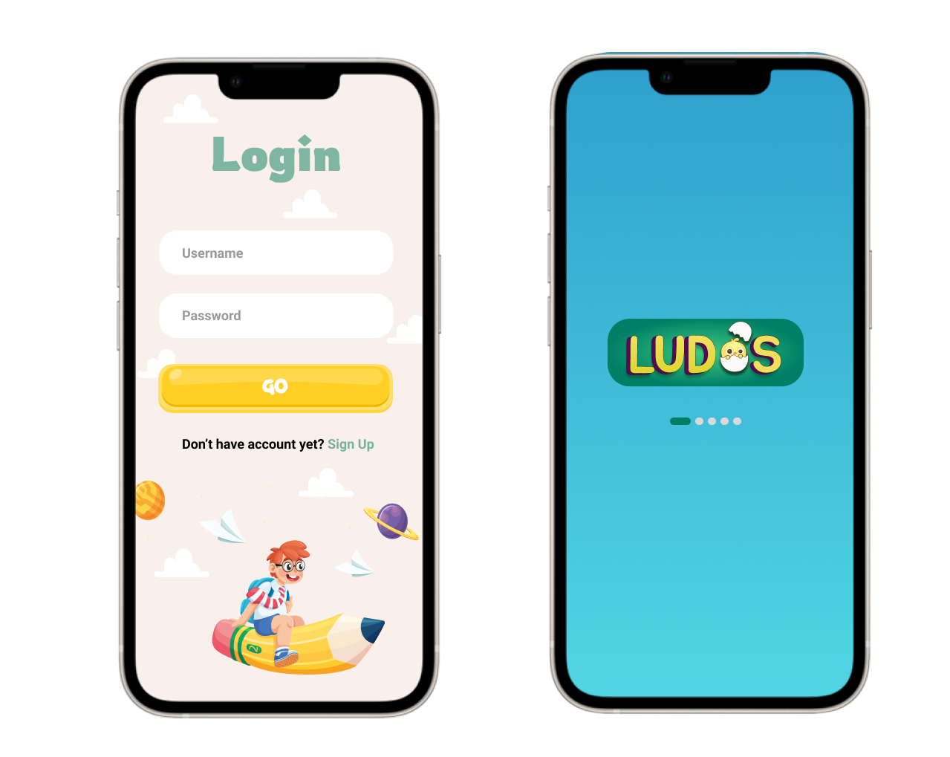

**Second main menu achievements page and settings**

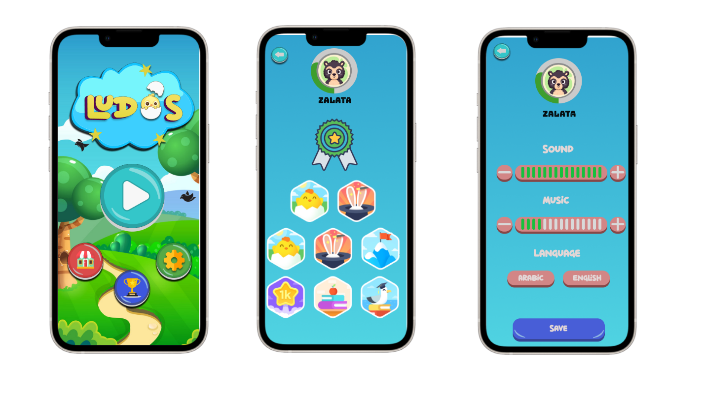

**Finally the games page and game preview**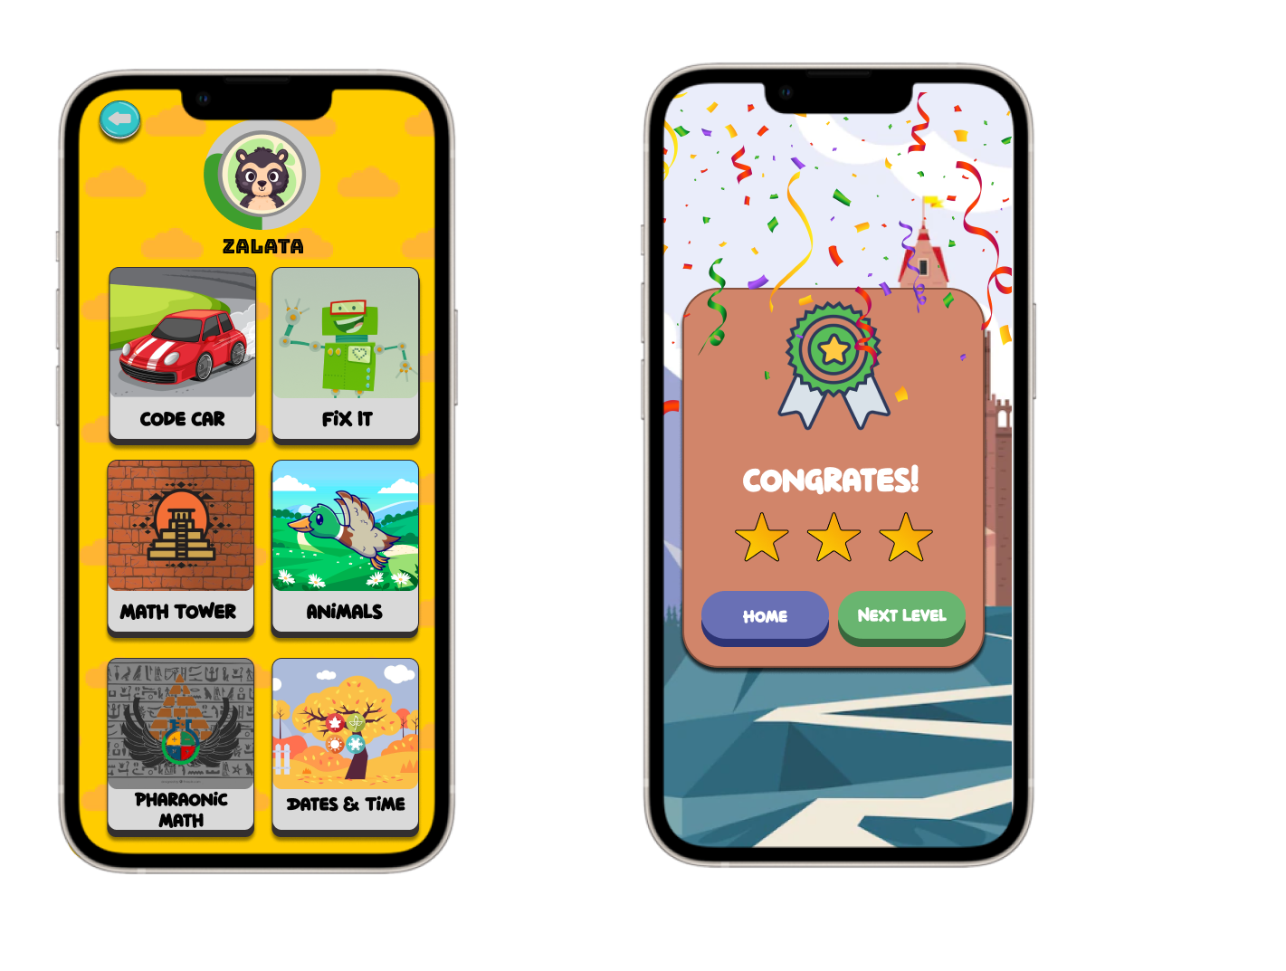

## 4 . 2 . **Database implementation**

As we mentioned in the system model the database, we chose is firebase for the previous reasons also because The Firebase Realtime Database enables safe access to the database from client-side code, enabling you to create robust, collaborative apps. To provide the end user with a responsive experience, data is locally persistent, and Realtime events continue to trigger even when the user is offline.

In the following syntax we take some information from the parent and add them to the database taking in mind handling every possible error we start by taking first his name , email , number of children

*public class Navigation : MonoBehaviour  
{  
  
 public void Start()  
 {  
 Application.targetFrameRate = 60;  
 }  
 public Animator animator;  
  
 IEnumerator loadScene(int index)  
 {  
 animator.SetTrigger("Start");  
  
 yield return new WaitForSeconds(1f);  
  
 SceneManager.LoadScene(index);  
 }  
 IEnumerator loadScene(string index)  
 {  
 animator.SetTrigger("Start");  
  
 yield return new WaitForSeconds(1f);  
  
 SceneManager.LoadScene(index);  
 }  
  
 /// <MainPages>  
 public void Navigate(int index)  
 {  
 StartCoroutine(loadScene(index));  
 }  
  
 public void NavToGames()  
 {  
 StartCoroutine(loadScene(1));  
 }  
 public void NavToSettings()  
 {  
 SceneManager.LoadScene(2);  
 }  
 public void NavToAchivments()  
 {  
 SceneManager.LoadScene(3);  
 }  
 public void NavToShop()  
 {  
 SceneManager.LoadScene(4);  
 }  
 ///<Games>  
 public void NavToMathTower()  
 {  
 SceneManager.LoadScene(12);  
 }  
  
 public void NavToAnimals()  
 {  
 SceneManager.LoadScene(5);  
 }  
 public void NavToCalender()  
 {  
 StartCoroutine(loadScene("Calendar-HomePage"));  
 }  
  
 // <Animals Levels>  
 public void AnimalsStory()  
 {  
 SceneManager.LoadScene(6);  
 GameManager.instance.animalsCurrentLevel = 0;  
 }  
 // <Math Tower Levels>  
 public void MathTowerLevel1()  
 {  
 SceneManager.LoadScene(13);  
 GameManager.instance.mathTowerCurrentLevel = 0;  
 }*

in the following lines we add more information for the child with the ability to change anything got wrong the parent can make changes and also update the data for his children

*public void AddChildren(string ChildName, int ChildAge)  
 {  
 parent.NumberOfChildrens++;// update number of children for parent   
 var parentnRef = firebaseFirestore.Collection("parent").Document(firebaseUser.UserId);  
 parentnRef.SetAsync(parent).ContinueWithOnMainThread(task =>  
 {  
 if (task.IsCompleted)  
 {  
 //Debug.LogFormat("firebaseUser add data is successfully: {0} ({1})", firebaseUser.DisplayName, firebaseUser.Email);  
 Debug.LogFormat("children {0} add successfully: ({1})", children.Name, firebaseUser.Email);  
 }  
 else  
 {  
 Debug.LogFormat("children {0} add Failed: ({1})", children.Name, firebaseUser.Email);  
 }  
 });  
 //object Avatar set Defalet 1  
 // cetriate child data  
 children = new Children(ID: parent.NumberOfChildrens , Avatar: 1,Name: ChildName,Age: ChildAge,Total_stars: 0,Achievements: new ArrayList() { },StoreItems: new ArrayList() { },Math: new ArrayList() { false },Calendar: new ArrayList() { false }, Animals: new ArrayList() { false });  
 var ChildrenRef = firebaseFirestore.Collection("parent").Document(firebaseUser.UserId).Collection("children").Document(parent.NumberOfChildrens.ToString());  
 ChildrenRef.SetAsync(children).ContinueWithOnMainThread(task =>  
 {  
 if (task.IsCompleted)  
 {  
 //Debug.LogFormat("firebaseUser add data is successfully: {0} ({1})", firebaseUser.DisplayName, firebaseUser.Email);  
 Debug.LogFormat("children {0} add successfully: ({1})", children.Name, firebaseUser.Email);  
 }  
 else  
 {  
 Debug.LogFormat("children {0} add Failed: ({1})", children.Name, firebaseUser.Email);  
  
 }  
 });  
 }*

in the following lines we save the data from the user first and if he want to logout a small clean code that help him navigate to the login again so he do not get lost after logging out

*public void LogOut()  
 {  
 Debug.LogFormat("user SignOut :{0} ({1}) ", firebaseUser.DisplayName, firebaseUser.Email);  
 firebaseAuth.SignOut();  
 AuthStateChanged(this, null);  
 UnityEngine.SceneManagement.SceneManager.LoadScene("FirebaseLogin");  
 }*

## **4 . 3 . Software implementation**

As we mentioned in (2.2.8. Chosen Framework) for these reasons we chose unity. Another key reason we chose Unity is because of its user-friendly interface and ease of use. Its drag-and-drop interface, visual scripting system, and wide range of pre-built assets and templates make it easy for our team to create and test our game mechanics quickly and efficiently and Unity is highly customizable and extensible, which means that we can tailor it to our specific project requirements and add additional functionality or features as needed. This level of flexibility is crucial for a project like ours.

In this next syntax we manage information from each level so we can send it to the parent email

And also he/she gets the achievements and can access the store

public class GameManager : MonoBehaviour

{

    public static GameManager instance;

    // todo: calculate starts for each game

    public int CalendarCurrentLevel; // -------------->>> LevelProgress

    public int CalendarNextLevel;   // -------------->>> LevelProgress

    public int CalendarStars;

    public int mathTowerCurrentLevel; // -------------->>> LevelProgress

    public int mathTowerNextLevel;     // -------------->>> LevelProgress

    public int mathTowerStars;

    public int animalsCurrentLevel; // -------------->>> LevelProgress

    public int animalsNextLevel; // -------------->>> LevelProgress

    public int animalsStars;

    private void Start()

    {

        CalendarCurrentLevel = AuthManger.Instance.children.TimeAndDate.Count - 1;

        CalendarNextLevel = AuthManger.Instance.children.TimeAndDate.Count;

        CalendarStars = 0;

        mathTowerCurrentLevel = AuthManger.Instance.children.Math.Count - 1;

        mathTowerNextLevel = AuthManger.Instance.children.Math.Count;

        mathTowerStars = 0;

        animalsCurrentLevel = AuthManger.Instance.children.Animals.Count - 1;

        animalsNextLevel = AuthManger.Instance.children.Animals.Count;

        animalsStars = 0;

        AuthManger.Instance.children.getTotalstars(AuthManger.Instance.children.Animals);

        Debug.Log("Game Manager class :: Math Current Level = " + $"{AuthManger.Instance.children.Math.Count - 1}");

        Debug.Log("Game Manager class :: Math Next Level = " + $"{AuthManger.Instance.children.Math.Count}");

    }

    private void Awake()

    {

        if (instance == null)

        {

            instance = this;

            DontDestroyOnLoad(gameObject);

        }

        else

        {

            Destroy(this.gameObject);

        }

    }

    public void UpdateData(string GameName, int level, int stars)

    {

        switch (GameName)

        {

            case "math":

            case "Math":

                if (AuthManger.Instance.children.Math.Count-1 < level) {

                    AuthManger.Instance.children.Math.Add(stars);

                    mathTowerNextLevel++;

                    mathTowerCurrentLevel++;

                    AuthManger.Instance.SendChildrenData(AuthManger.Instance.children.ID);

                }

                else if (System.Convert.ToInt32(AuthManger.Instance.children.Math[level]) < stars)

                {

                    Debug.Log(System.Convert.ToInt32(AuthManger.Instance.children.Math[level]));

                    AuthManger.Instance.children.Math[level] = stars;

                    AuthManger.Instance.SendChildrenData(AuthManger.Instance.children.ID);

                }

                break;

            case "animals":

            case "Animals":

                if (AuthManger.Instance.children.Animals.Count - 1 < level)

                {

                    AuthManger.Instance.children.Animals.Add(stars);

                    animalsNextLevel++;

                    animalsCurrentLevel++;

                    AuthManger.Instance.SendChildrenData(AuthManger.Instance.children.ID);

                }

                else if (System.Convert.ToInt32(AuthManger.Instance.children.Animals[level])< stars)

                {

                    AuthManger.Instance.children.Animals[level] = stars;

                    AuthManger.Instance.SendChildrenData(AuthManger.Instance.children.ID);

                }

                break;

            case "calendar":

            case "Calendar":

                if (AuthManger.Instance.children.TimeAndDate.Count - 1 < level)

                {

                    CalendarNextLevel++;

                    CalendarCurrentLevel++;

                    AuthManger.Instance.children.TimeAndDate.Add(stars);

                    AuthManger.Instance.SendChildrenData(AuthManger.Instance.children.ID);

                }

                if (System.Convert.ToInt32(AuthManger.Instance.children.TimeAndDate[level] )< stars)

                {

                    AuthManger.Instance.children.TimeAndDate[level] = stars;

                    AuthManger.Instance.SendChildrenData(AuthManger.Instance.children.ID);

                }

                break;

            default:

                Debug.LogError("Game Manager class :: UpdateData GameName not match");

                break;

        }

    }

}

We also put in mind not to reload any game that not in use so we can make it load less on the CPU of the device and does not conflict with each other.

// Singelton

  private void Awake()

    {

        if (instance == null)

        {

            instance = this;

            DontDestroyOnLoad(gameObject);

        }

        else

        {

            Destroy(this.gameObject);

        }

    }

There are also several function to update the levels and the progress of each child in the game itself.

switch (GameName)

        {

            case "math":

            case "Math":

                if (AuthManger.Instance.children.Math.Count-1 < level) {

                    AuthManger.Instance.children.Math.Add(stars);

                    mathTowerNextLevel++;

                    mathTowerCurrentLevel++;

                    AuthManger.Instance.SendChildrenData(AuthManger.Instance.children.ID);

                }

                else if (System.Convert.ToInt32(AuthManger.Instance.children.Math[level]) < stars)

                {

                    Debug.Log(System.Convert.ToInt32(AuthManger.Instance.children.Math[level]));

                    AuthManger.Instance.children.Math[level] = stars;

                    AuthManger.Instance.SendChildrenData(AuthManger.Instance.children.ID);

                }

                break;

5 . Chapter Five: System Testing

## 5 . 1 . **Unit Testing**

Unit testing is a software testing technique that focuses on testing individual units or components of a software system in isolation. In unit testing, each unit is tested independently to ensure that it behaves as expected.

A unit refers to the smallest testable part of a software system, such as a function, method, or class. The goal of unit testing is to verify that each unit performs its intended functionality correctly and produces the expected output for a given set of inputs.

Used strategies

Isolation: Unit tests are designed to be isolated from external dependencies, such as databases. This is achieved by using techniques like stubbing to simulate the behavior of these dependencies.

Test Cases: Unit tests are written as individual test cases, each targeting a specific behavior or functionality of a unit. Test cases define the inputs to the unit and the expected outputs or behaviors that should be observed.

## 5 . 2 . **Integration Testing**

Integration testing is a software testing technique that focuses on testing the interactions and integration between different components or modules of a software system. It aims to identify defects that may arise from the interaction of these components when they are integrated together.

In integration testing, individual components are combined and tested as a group to ensure that they work together correctly. It goes beyond unit testing, which tests individual components in isolation, and examines how these components communicate, share data, and collaborate with each other.

Types of Integration Testing: There are different levels of integration testing, including:

a. Top-Down: Starts with testing the highest-level components or modules first and gradually integrates lower-level components. Stub or mock objects may be used to simulate the behavior of lower-level components during early stages of testing.

b. Bottom-Up: Begins with testing the lowest-level components and gradually adds and tests higher-level components. Test drivers may be used to simulate the behavior of higher-level components during early stages of testing.

c. Sandwich/Hybrid: Combines both top-down and bottom-up approaches, aiming to find issues in the interaction between components at different levels of the system hierarchy.

We used this strategy in our testing integration.

d. Big Bang: All components are integrated and tested together at once. This approach is typically used when the system architecture allows for a straightforward integration and when the individual components have been thoroughly tested.

## 5 . 3 . **System Testing**

**Register Cases**

|  |  |  |  |  |
| --- | --- | --- | --- | --- |
| Input | Expected output | | Actual output | Comment |
| Name: Enter Name  Email: Enter email  Password: Enter password  Confirm pass: Confirm password | Go to login page | |  | Registered |
| Name: empty  Email: empty  Password: empty Confirm password:  empty | | Missing username |  | Please put username |
| Name: complete  Email: empty  Password: empty Confirm password:  empty | | Missing Email |  | Please put Email |
| Name: complete  Email: complete  Password: empty Confirm password:  empty | | Missing Password |  | Please put Password |
| Name: complete  Email: complete  Password: complete  Confirm password:  complete | | Weak password |  | Please put strong password |

**Login case**

|  |  |  |  |
| --- | --- | --- | --- |
| Name: complete  Password: complete | Home page |  | Go to home page |
| Name: complete  Password: complete | Wrong email |  | Invalid email |
| Name: complete  Password: complete | Wrong password |  | Wrong password |

# 6 . **Chapter Six: Conclusion & Future Work**

we're always looking to improve and add new features to enhance the user experience and make the kids have more fun and learn more from the application.

First thing we are going to add is more games for the children so we can expand their knowledge more and more

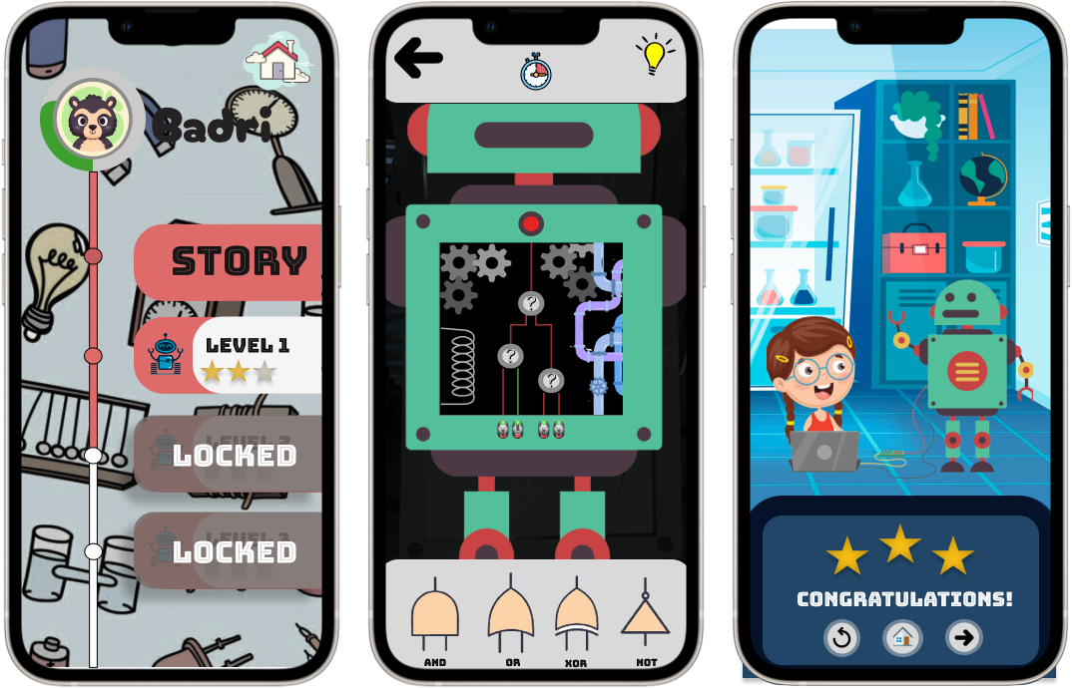

**Description**

To attract the child attention first we will make the robot talk with them and do some cool things then the robot will get some damage and not work and a girl will appear and help them by teaching the kids about the logic gates and how the robot work form inside this will make the children interested in helping the robot. the girl will talk about in detailed way and at the same time with many animations so the kids never get bored then they will proceeds to the gameplay which will make them actually fix the robot.

**GAMEPLAY**

First, we'll start with some basics. The kids will be presented with a digital circuit inside the robot that needs to be completed by adding logic gates. They will have a limited set of logic gates to choose from, and they will need to use them in the right order to make the circuit work. And there will be a system to inform them about their progress and if the gate is on or off . Each level will get progressively harder, adding more complex circuits and more challenging logic puzzles.

As they progress through the game, they will unlock new logic gates and other components that will help you build more advanced circuits. They will also learn about the different types of logic gates, such as AND gates, OR gates, and NOT gates, and how they can be combined to create more complex circuits.

At each level. They will be able to test the circuit to see if it works. when it works the red light will be green so that they know the gate is on If it doesn't work, you'll need to go back and adjust your logic gates until it works as intended. You'll also be able to see a visual representation of the circuit inside the robot, showing how the different logic gates are working together to make the robot works.

Even after they finish fixing the robot we will add more visual character like rockets and cars and make them fix it to make sure they understand it perfectly.

**CONCLUSION**

So that's a quick overview of our new game that will teach you about logic gates. We're excited to see how you do and how you enjoy learning about this important topic. Remember, logic gates are a key part of modern technology, and understanding how they work can help you build your own electronics projects in the future.

**Second game**



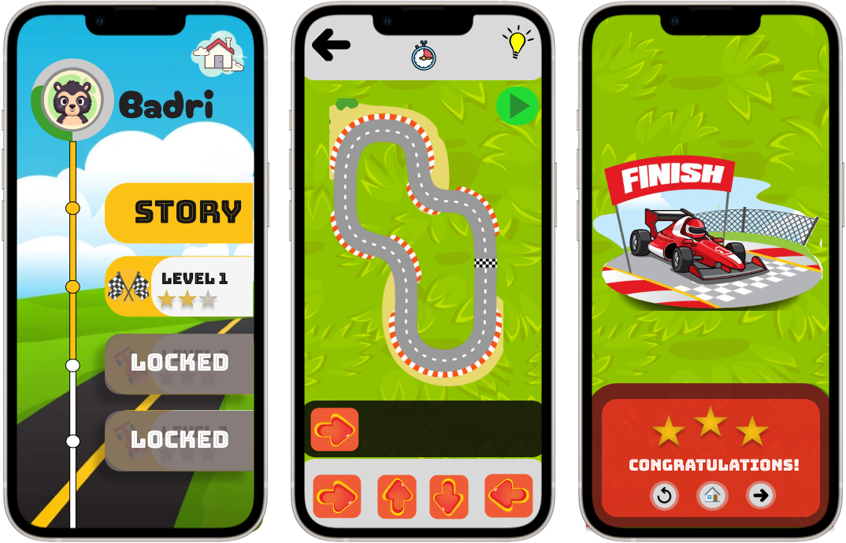

**Description**

a game that will challenge kids to think creatively, work through obstacles, and find solutions to complex problems. In this game, they will have to use there imagination and critical thinking skills to overcome challenges and progress through each level. By making them interested in moving the car the right way.

**GAMEPLAY**

At the beginning of each level, you'll be presented with a car track that needs to move the car on. This might include things like puzzles, mazes, or obstacles that you'll need to navigate around or over. You'll need to use your problem-solving skills to find a solution and progress to the next level.

To help the kids along the way, they will have access to a variety of tools and power-ups that can help them solve problems and progress through the game. These might include things like nitro or signs and other tools that can help them navigate obstacles and find solutions.

Throughout the game, they will be encouraged to experiment and try different approaches to solving problems. they might need to backtrack, try a different strategy, or use a combination of tools and power-ups to find a solution.

As kids progress through the game, they'll encounter more complex problems and challenges that will require more creative thinking and problem-solving skills to solve. they might encounter roadblock or other hazards that kids will need to overcome using there wits and problem-solving skills.

**CONCLUSION**

So that's a quick overview of the new game that will teach children how to be a master problem solver! and how kids enjoy learning about creative thinking and finding solutions to complex problems. Remember, problem-solving is an important skill that can help you in all areas of life, from school to work to personal projects.

**Third game**



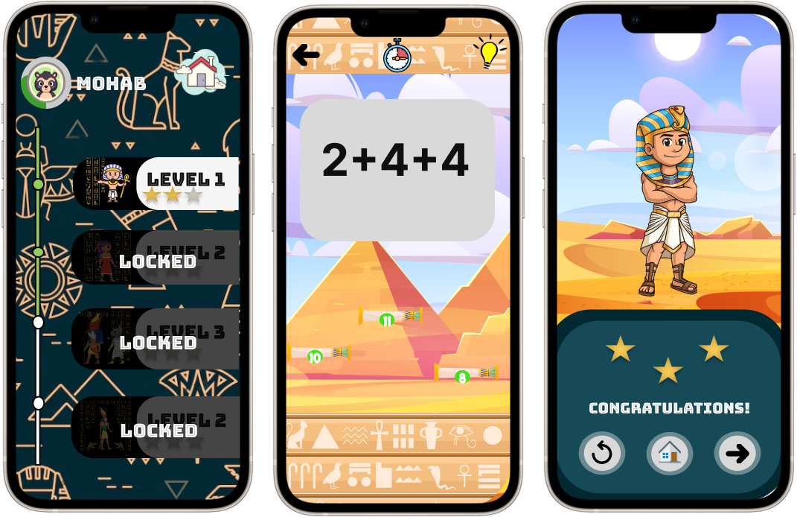

**Description**

we already have a game that teach the kids some math but this one is more advanced with more complex operations. they'll have the opportunity to learn math while having fun like the part one . they'll be able to improve there math skills and practice what you've learned in part one in a fun and interactive way.

**GAMEPLAY**

The game will present children with a series of math problems to solve, each with different levels of difficulty. they'll be able to choose the difficulty level that's best for them by taking a quiz at the start, and also kids will have a set amount of time to solve as many problems as they can.

The types of math problems children will encounter will include multiplication and division and square and many other math operations. The game will gradually get more challenging as they progress, with more complex problems that require more advanced math skills.

To help kids along the way, they'll have access to various tools that can help you solve problems and progress through the game. These might include things like extra time, hints, or bonus points.

While they walk with the character with is pharaoh they will escape enemies by solving the problems and jump on they right answer.

**CONCLUSION**

So that's a quick overview of pharaonic math the best outcomes always comes out of enjoyment so we hope they will be happy and having fun while learning math. Remember, math is an important skill that can help you in many areas of life.

**Forth game**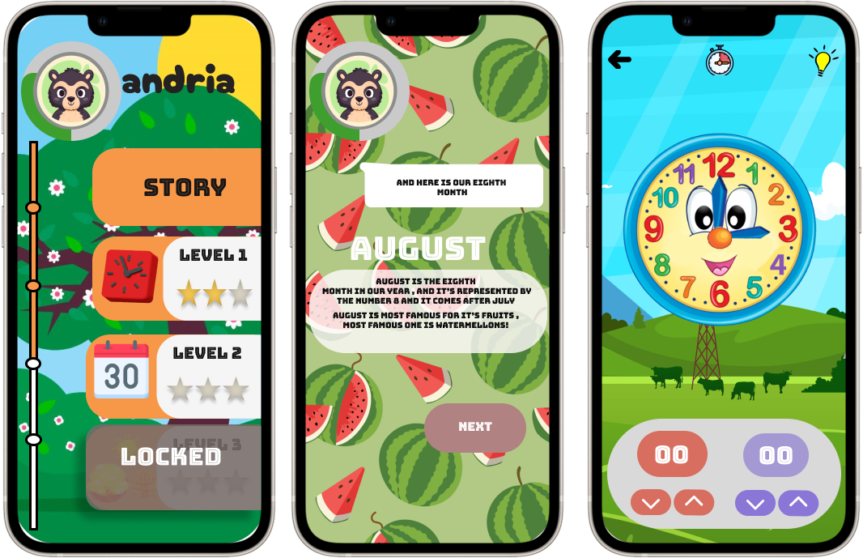

**Description**

Kids will learn how to tell time using both analog and digital clocks. Also they will learn about the different units of time, including seconds, minutes, and hours.

**GAMEPLAY:**

The game will present kids with a series of challenges related to telling time. they'll need to read the time on an analog clock, a digital clock, or both. they'll also need to convert between different units of time, such as seconds to minutes or hours to minutes.

**CONCLUSION**

We hope kids will enjoy learning about time while having fun Remember, time is an important concept that affects many areas of life by knowing more about time kids will learn to value it more and make efficient schedules.

We also but in mind to make a website for the app to make it easier for the parents to know more about the application and make the progress more easier for them

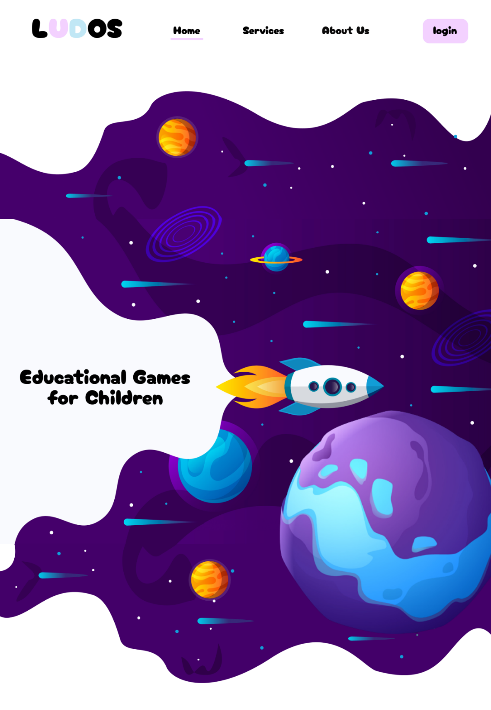# Home

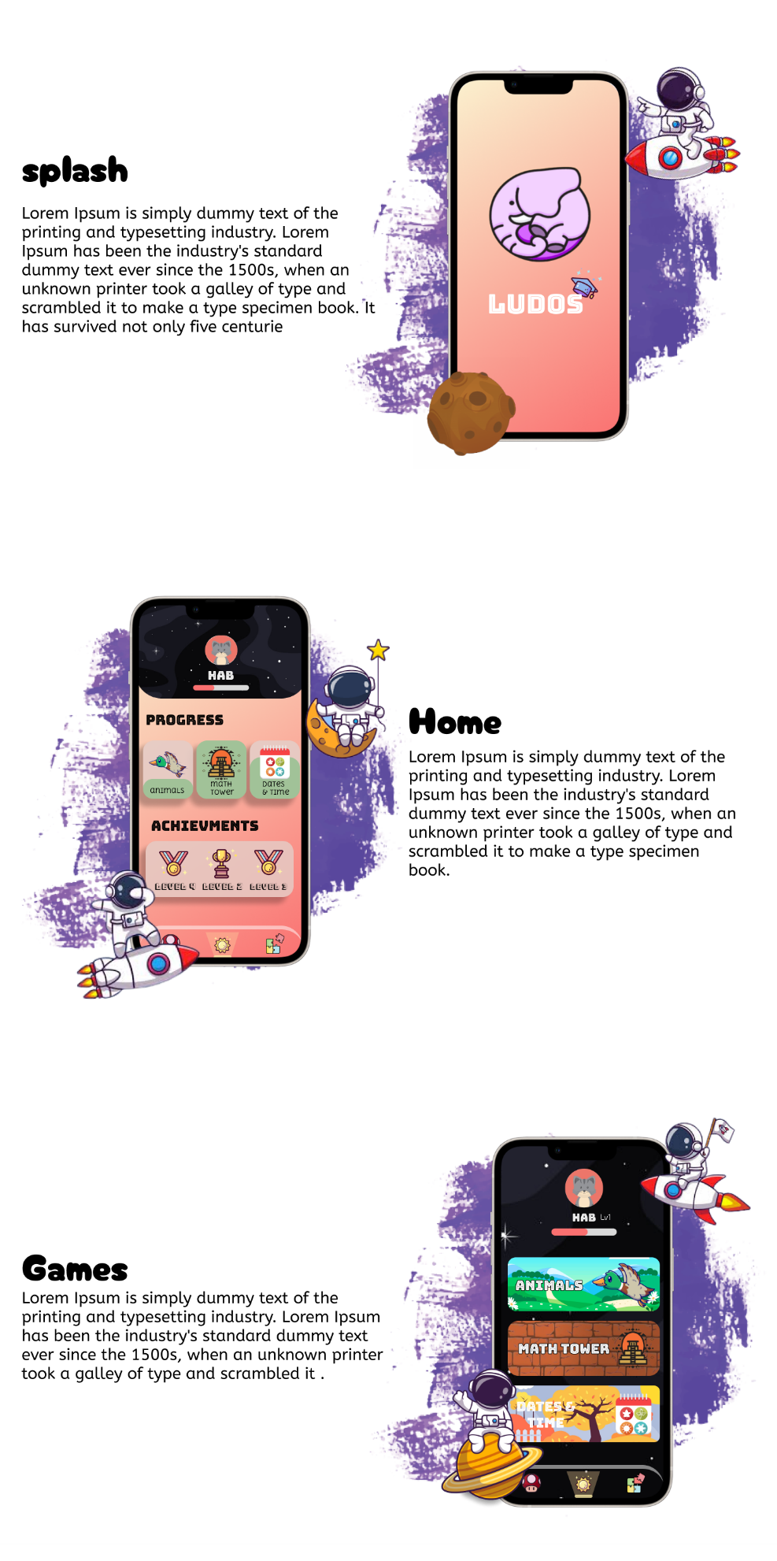

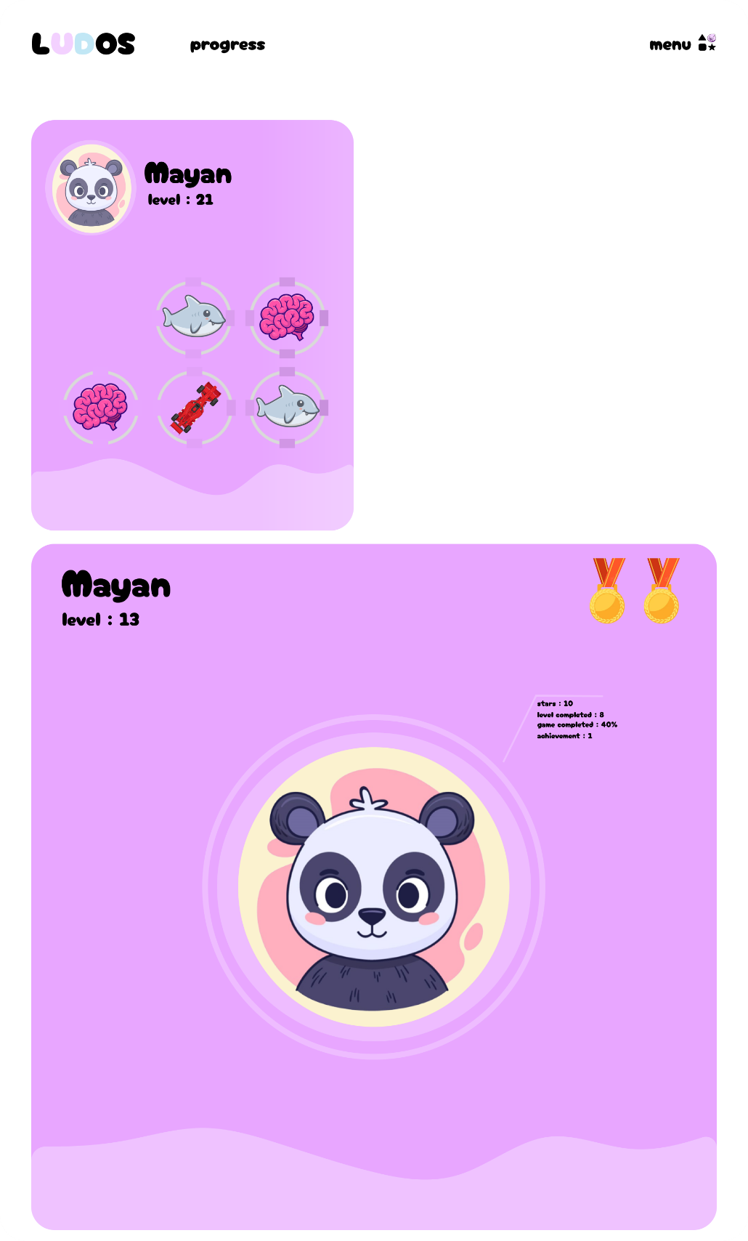# Progress

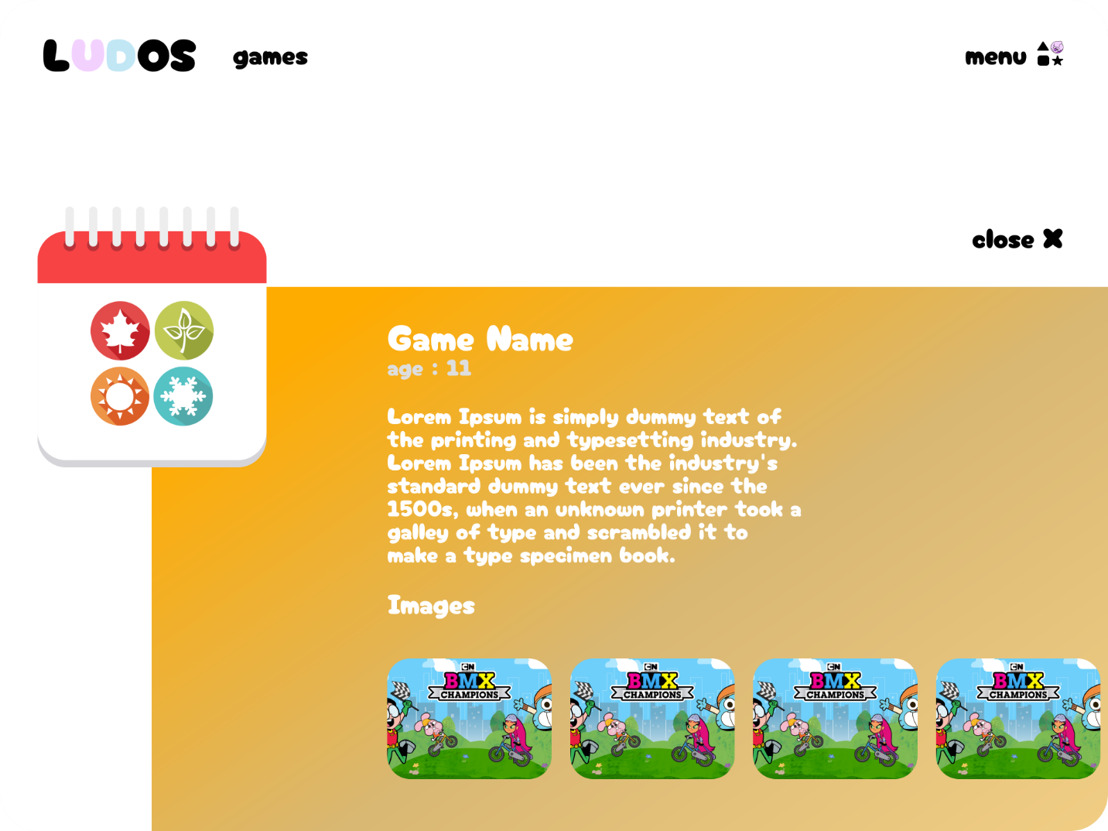# Games

**We are willing to not only add games put also add more features to the app itself like**

**PUSH NOTIFICATIONS**

First on our list is push notifications., such as reminder to the game or services. We'll be implementing this feature using a third-party service to ensure reliable delivery and easy management. Users will be able to customize their notification settings in the app's settings menu, and we'll be providing clear guidance on how to enable or disable notifications as needed.

**IN-APP MESSAGING**

Next up, we'll be adding an in-app messaging system. This will allow parents to communicate with each other directly within the app, without having to switch to a separate messaging app. We'll be using a real-time messaging service to ensure fast and reliable communication, and we'll be implementing several security features to protect user privacy and prevent spam or abuse. parents will be able to see their messaging history, manage their contacts, and customize their messaging settings in the app's messaging menu.

**ACCESSIBILITY IMPROVEMENTS**

Another area we're focusing on is accessibility. We want our app to be usable by as many people as possible, so we'll be making some changes to improve accessibility for users with disabilities. This includes adding support for screen readers, improving contrast and font sizes, and adding alternative text to images. We'll be following accessibility guidelines and best practices to ensure that our app is easy to use for all users, regardless of their abilities.

**PERFORMANCE OPTIMIZATIONS**

we'll be working on some performance optimizations to make the app run faster and smoother. We'll be analyzing user feedback and usage patterns to identify areas where we can improve performance and reduce load times. This includes optimizing the app's code and assets, using caching and compression where possible, and testing the app on a variety of devices and network conditions to ensure optimal performance.

**Dashboard**

we also going to put a dashboard for the kids to make the game a little more competitive make them race on getting scores and learning better thus will make the kid compete and in many cases they will end up friends with each other which will be good to the children’s healthy life.

**Personalization**

We will be adding more features that allow users to personalize their experience. This could include customizing the app's color scheme, creating a profile, or choosing their own background images.

**More Content**

We are constantly working to add new content to our app, such as new videos for kids, articles, or games. We will also be adding new categories and topics.

**Conclusion**

the game-based learning app has proven to be a highly effective and engaging tool for educational purposes. Throughout its development and implementation, it has successfully combined the elements of gaming and learning, resulting in a unique and impactful experience for kids.

The app's interactive and immersive gameplay has fostered a positive learning environment, encouraging active participation and knowledge retention. By incorporating educational content into engaging challenges, the app has effectively captured the attention and interest of kids, making the learning process enjoyable and motivating.

Moreover, the game-based learning app has demonstrated its potential to cater to diverse learning styles and preferences. Through its dynamic and adaptive nature, it accommodates individual progress, allowing kids to learn at their own pace. This personalized approach has enhanced the effectiveness of the learning experience, as users can focus on areas that require additional attention and reinforcement.

Furthermore, the app has provided children with valuable opportunities to develop essential skills beyond the subject matter being taught. Critical thinking, problem-solving, collaboration, and decision-making skills have been nurtured through the app's challenging and thought-provoking gameplay.

Additionally, the app's progress tracking and assessment features have enabled both children and family to monitor learning outcomes and identify areas for improvement.

Overall, the game-based learning app has revolutionized the way we approach education. By harnessing the power of gaming, it has transformed learning into a fun and engaging experience, maximizing learner motivation and knowledge retention. The app's ability to cater to diverse learning styles and promote the development of critical skills further underscores its significance as a tool for educational advancement. As we continue to embrace technology in education, the game-based learning app stands as a prime example of the potential to enhance learning outcomes and create a brighter future for learners worldwide.

# **References**

[1] Mlumun, Yugh Sandra, et al. "Intellectual Impact of Mobile Educational Games on Secondary School Education in Nigeria: Case Study of Government Girls' College Makurdi." *American Journal of Information Science and Technology* 5.3 (2021): 48-59.

[2] Narzikulovich, N. N. . (2022). Development of Physical Qualities of Preschool Children by Means of Mobile Games. International Journal of Discoveries and Innovations in Applied Sciences, 2(2), 45–48.

[3] Yu, Z., Gao, M., & Wang, L. (2021). The effect of educational games on learning outcomes, student motivation, engagement and satisfaction. *Journal of Educational Computing Research*, *59*(3), 522-546.‏

[4] Papadakis, S., Alexandraki, F. & Zaranis, N. Mobile device use among preschool-aged children in Greece. *Educ Inf Technol* **27**, 2717–2750 (2022).

[5] Shufang Tan, Wendan Huang, Junjie Shang, Research Status and Trends of the Gamification Design for Visually Impaired People in Virtual Reality, HCI in Games, 10.1007/978-3-031-05637-6_41, (637-651), (2022).

[6] Gillett-Swan, J., Thelander, N. (2021). Child Rights Knowledge and Children’s Education Rights. In: Gillett-Swan, J., Thelander, N. (eds) Children’s Rights from International Educational Perspectives. Transdisciplinary Perspectives in Educational Research, vol 2. Springer, Cham.

[7] Zheng, Y. (2021). New Ideas for College Physical Education Development Under the Background of “Internet+ Education”. In: Xu, Z., Parizi, R.M., Loyola-González, O., Zhang, X. (eds) Cyber Security Intelligence and Analytics. CSIA 2021. Advances in Intelligent Systems and Computing, vol 1343. Springer, Cham.

[8] Al Abdullatif, Ahlam & Gameil, Azza. (2020). Exploring Students' Knowledge and Practice of Digital Citizenship in Higher Education. International Journal of Emerging Technologies in Learning (iJET). 15. 122-142. 10.3991/ijet.v15i19.15611.

[9] Mkpojiogu, Emmanuel & Hussain, Azham & Onah, Monday. (2021). Security Issues in the Use of Mobile Educational Apps: A Review. International Journal of Interactive Mobile Technologies (iJIM). 15. 124-137. 10.3991/ijim.v15i06.20631.

[10] Du, Y. (2021). Interactive Design Principles of Educational APP Interface. In: Sugumaran, V., Xu, Z., Zhou, H. (eds) Application of Intelligent Systems in Multi-modal Information Analytics. MMIA 2021. Advances in Intelligent Systems and Computing, vol 1385. Springer, Cham.

[11] Parrilli, D.M., Hernández-Ramírez, R. (2022). Building a Privacy Oriented UI and UX Design: An Introduction to Its Foundations and Potential Developments. In: Martins, N., Brandão, D. (eds) Advances in Design and Digital Communication II. DIGICOM 2021. Springer Series in Design and Innovation , vol 19. Springer, Cham.

[12] Cao, H., Guo, J. (2020). Research on the User Experience of Educational App in the Context of “Intangible Cultural Heritage”. In: Ahram, T., Falcão, C. (eds) Advances in Usability, User Experience, Wearable and Assistive Technology. AHFE 2020. Advances in Intelligent Systems and Computing, vol 1217. Springer, Cham.

[13] Chang, WL., Lu, WH. (2021). Building Common Ground: Applying Mutual Learning in the UI/UX Education. In: Kurosu, M. (eds) Human-Computer Interaction. Theory, Methods and Tools. HCII 2021. Lecture Notes in Computer Science(), vol 12762. Springer, Cham.

[14] Nielsen, J.: A 100-year view of user experience (by Jakob Nielsen). Accessed 11 Feb 2021

[15] Ketut Sintia Kesuma Dewi, Padmadewi, N. N., & Dewi, K. S. (2022). An Analysis Analysis of Reward System Used in Blended Learning Strategy to Develop Students’ Learning Motivation at North Bali Bilingual School. *Innovative Education Journal*, *1*(1), 58–63.

[16] Journal of Educational Research and EvaluationVolume 4, Number 3,Tahun 2020, pp. 307-314P-ISSN: 2597-422x E-ISSN: 2549-2675

[17] Haryanto, Hanny, Ardiawan Bagus Harisa, and Indra Gamayanto. "Appreciative Learning for Immersive Reward System in Education Game Development." *Journal of Games, Game Art, and Gamification* 6.2 (2021): 32-38.

[18] M. Morsidi, S. Tajuddin, R. K. Patchmuthu and S. H. S. Newaz, "Blockchain-based Reward System: a Means for Providing Incentive to Students for Teaching Feedback," 2021 International Conference on Electronics, Communications and Information Technology (ICECIT), 2021, pp. 1-5, doi:

[19] Zou, F., Cao, Y. (2020). Integrating Educational Content into Game: An Encapsulation Method. In: Shen, J., Chang, YC., Su, YS., Ogata, H. (eds) Cognitive Cities. IC3 2019. Communications in Computer and Information Science, vol 1227. Springer, Singapore.

[20] Tan Kim Hua A Comparison of Online Learning Challenges Between Young Learners and Adult Learners in ESL Classes During the COVID-19 Pandemic, Vol. 12, No. 1, pp. 28-35, January 2022.

[21] The Author(s) 2021 17 J. Ryoo, K. Winkelmann (eds.), Innovative Learning Environments in STEM Higher Education, SpringerBriefs in Statistics.

[22] Bulut, D., Samur, Y. & Cömert, Z. The effect of educational game design process on students’ creativity. *Smart Learn. Environ.* **9**, 8 (2022).

[23] Kearney, M., Burden, K., Schuck, S. (2020). Differentiating Mobile Learning Frameworks. In: Theorising and Implementing Mobile Learning. Springer, Singapore.

[24] Mejía, J., Maciel, P., Muñoz, M., Quiñonez, Y. (2020). Frameworks to Develop Secure Mobile Applications: A Systematic Literature Review. In: Rocha, Á., Adeli, H., Reis, L., Costanzo, S., Orovic, I., Moreira, F. (eds) Trends and Innovations in Information Systems and Technologies. WorldCIST 2020. Advances in Intelligent Systems and Computing, vol 1160.

[25] Santana Quintero, M., Duong, M., Smith, L. (2022). Developing an Ethical Framework for the Digital Documentation of Heritage Sites. In: Ch'ng, E., Chapman, H., Gaffney, V., Wilson, A.S. (eds) Visual Heritage: Digital Approaches in Heritage Science. Springer Series on Cultural Computing. Springer, Cham.

[26] Murphy, B. M., Russell, K. L., Stillwell, C. C., Hawley, R., Scoggins, M., Hopkins, K. G., ... & Smith, R. F. (2022). Closing the gap on wicked urban stream restoration problems: A framework to integrate science and community values. *Freshwater Science*, *41*(3), 000-000.

[27] Rao, P. Srinivasa, et al. "DISTINCTION OF MOBILE FRAMEWORKS: FLUTTER VS NATIVE APPS.", Volume:04/Issue:06/June-2022.

[28] Jayasinghe, M.J.W., Hennayaka, W.H.M.A.D.H., Fernando, M.P.M., Thilakarathne, K.N.U., Samarakoon, U., Kumari, S. (2022). **LEXISGURU: Mobile Application for Learning Basic Lexis in English** for Kids. In: Auer, M.E., Tsiatsos, T. (eds) New Realities, Mobile Systems and Applications. IMCL 2021. Lecture Notes in Networks and Systems, vol 411. Springer, Cham.

[29] Rocha, T., Barroso, J. (2021). PLAY for LEARNING: Serious Games to Assist Learning of Basic Didactic Concepts: A Pilot Study. In: Fang, X. (eds) HCI in Games: Serious and Immersive Games. HCII 2021. Lecture Notes in Computer Science(), vol 12790. Springer, Cham.

[30] Wang, J. *et al.* (2021). A Study on Serious Game Practice to Improve Children’s Global Competence. In: Fang, X. (eds) HCI in Games: Serious and Immersive Games. HCII 2021. Lecture Notes in Computer Science(), vol 12790. Springer, Cham.

[31] Ergasheva, Madina Toyir Qizi. "THE BENEFITS OF TEACHING ENGLISH THROUGH GAMES." *Scientific progress* 2.7 (2021): 369-371.

[32] Vuković, Predrag, and Anamarija Juras. "APPLICATION OF DIDACTIC GAMES IN MATHEMATICS TEACHING." *childhood* 17 (2022): 18.

[33] Barr, Matthew, and Alicia Copeland-Stewart. "Playing video games during the COVID-19 pandemic and effects on players’ well-being." *Games and Culture* 17.1 (2022): 122-139.

[34] Abd-Alrazaq, Alaa, et al. "The effectiveness of serious games in improving memory among older adults with cognitive impairment: systematic review and meta-analysis." *JMIR serious games* 10.3 (2022): e35202.

[35] Moving from Unity to Godot, 2020, ISBN : 978-1-4842-5907-8

[36] Kishan Takoordyal, Beginning Unity Android Game Development, 2020, 978-1-4842-6002-9.

[37] Beginning Unreal Engine 4 Blueprints Visual Scripting, 2021 ISBN : 978-1-4842-6395-2

[38] Zagalo, N., Oliveira, A.P., Cardoso, P. (2021). Beats and Units Framework: A Story-Game Integration Framework for the Ideation Stage of Narrative Design of Serious Games. In: Mitchell, A., Vosmeer, M. (eds) Interactive Storytelling. ICIDS 2021. Lecture Notes in Computer Science(), vol 13138. Springer, Cham.

[39] Entertainment for Education. Digital Techniques and Systems, 2010, Volume 6249

ISBN : 978-3-642-14532-2 Wenfeng Hu

[40] (2008). Introduction to Software Architecture. In: Software Architecture. Advanced Topics in Science and Technology in China. Springer, Berlin, Heidelberg. https://doi.org/10.1007/978-3-540-74343-9_1